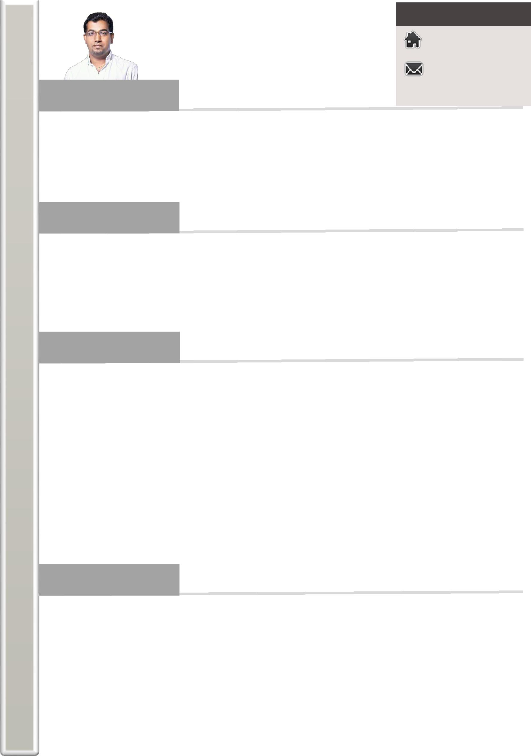
Contact Details

VINOD

Vinod.148850@2freemail.com

Career Summary

I am a B.com. Graduate with a strong background in financial accounting. I am an experienced Accountant, who has brilliantly managed all aspects of the accounting, from the preparation of Journals to preparation of financial Statements. I have more than seven years of experience as an Accountant at Manufacture Company, Production Industry, and Government Educational Institution. Most recently I have been promoted twice for my best performances. I am a person with the blend of technical and accountant environment, so right now I am looking for an opportunity to apply my technical expertise along with my Accountant skills, for a dynamic and progressive organization.

Academic Career

- Certificated Course in Financial Accounting with Tally - CCFAT (A-1 Grade), India

- Bachelor in Commerce (B.Com.), University of Karnataka, India

- Certified Skilled Mechanical Technician (SMT–Qualified), Singapore

- Diploma In Mechanical Engineering, India

- Higher Secondary School Certificate (A-1 Grade), India

- Secondary School Certificate (A-1 Grade), India

Career Path

- GOOD SHEPHERD CONVENT GOVT. COMPOSITE.P.U.COLLEGE, INDIA

CHIEF ACCOUNTANT AND ASSISTANT ADMIN. – (Jun 2013 to Dec 2016)

ACCOUNTANT – (Jun 2011 to May 2013)

- AUTOMOTIVE AXLES LIMITED, INDIA

JUNIOR ACCOUNTANT. – (Feb 2010 to Apr 2011)

- INFLOW SYSTEMS & SERVICES (S) PTE LTD, SINGAPORE

PRODUCTION ENGINEER. – (Jun 2006 to Dec 2009) MECHANICAL DRAFTSMAN – (May 2004 to April 2006)

- BHARAT HEAVY ELECTRICAL LIMITED – BHEL, INDIA

JUNIOR ACCOUNTANT - PLANNING – (DEC 2003 to Apr 2004)

TRAINEE - FACTORY SERVICES & PLANNING – (AUG 2002 to Nov 2003)

Key Skills

- Have excellent Knowledge & Experience of Accounting Cycles from preparation of Journals to preparation of financial Statements.

- Have an ability to work under pressure, can meet strict deadlines with efficiency & accuracy.

- Have excellent knowledge of ERPs & Accounting Software.

- Have fluent skills in monthly closing books of accounts monthly & quarterly provisions.

- Have excellent command on a implementation of comparison reports & preparing annual budgets.

- Highly adept in formulation of Policies & strategies according to the organization requirement.

- Have Strong self-confidence, problem-solving, job task planning and critical thinking skills.

- Having highly professional, competent, & ethical in approach.

- Have got excellent communication & highly fluent in English.

Professional Experiences

- GOOD SHEPHERD CONVENT GOVT. COMPOSITE.P.U.COLLEGE, INDIA

CHIEF ACCOUNTANT AND ASSISTANT ADMIN.
  - Prepared Monthly, Quarterly & Annual Financial Statements.

  - Responsible for reporting to Management Secretary.

  - Coordinated with Bank authorities for all the day to day Issues.

  - Prepared investment appraisals & implementing strategies to improve working capital.

  - Directed internal audits involving there view of accounting and administrative controls.

  - Analyzed the data to develop effective strategic policy.

  - Provided recommendations for coming year & implementing controls by effective budgeting & forecasting.

  - Assisted external auditors in yearly audit.

  - Prepared of asset report, income & expenditure report.

  - Implemented student tracking system, school management software, controls, & systems.

  - Arranged for programs, functions, and staff, parents meetings.

- GOOD SHEPHERD CONVENT GOVT. COMPOSITE.P.U.COLLEGE, INDIA

ACCOUNTANT
  - Maintained books of accounts.

  - Managed all Accounts Payables & Accounts Receivables

  - Maintained payroll & Petty Cash expenses & fund transfer-RTGS, NEFT.

  - Carried out Bank reconciliation & finalization of accounts.

  - Responsible for fee collection & voucher invoice.

  - Invited quotations, tenders for the supply of machine needs and maintenance services.

    - Prepared letters correspondence in office, clients and suppliers regarding confirmations.

    - Interacted with suppliers, regarding negotiations of products and machines, issue purchase order, payments.

- AUTOMOTIVE AXLES LIMITED, INDIA

JUNIOR ACCOUNTANT
  - Maintained of the general ledger and related accounts with proper documentation and records of bank transactions

  - Responsible for reporting to Chief Financial Officer.

  - Prepared monthly bank reconciliations.

  - Maintained preparing payroll, estimates, tender documents, running & final bills

- INFLOW SYSTEMS & SERVICES (S) PTE LTD, SINGAPORE

PRODUCTION ENGINEER
  - Explained & allotted brake up drawings to workshop & explaining for easy understanding.

  - Procurement of raw materials, tools, & equipment’s.

  - Assigning duties and shifts to section staff.

  - Scheduled weekly, monthly maintenance of machineries.

  - Informed to management regarding production related purchases, quality control.

  - Intimated management regarding up-to-date on the status of the work process.

  - Ensuring customer requirement by joint analysis with R&D.

  - Interaction with Clients to meet their design & production requirements.

- INFLOW SYSTEMS & SERVICES (S) PTE LTD, SINGAPORE

MECHANICAL DRAFTSMAN
  - Visiting the client’s spot for complete survey & detailed layout measurements.

  - Designing of the clean room machine structures and assembly lines.

  - Creation of detail assembly & machine manufacturing drawings using AutoCAD.

  - Providing brake up drawings to workshop & explaining for easy understanding.

  - Designing tool for Ultrasonic welding machines & creation of Bill of Material.

Computer skills

- Excellent knowledge, experience, & understanding of MS Office & Outlook.

- Excellent command on Accounting Software as Tally-ERP’s, AutoCAD-(R14 & R2000), Electrical/Mechanical Drafting.

Personal Information

• | Father Name | : Mr. Fedrick D’Souza
•
• | Gender | : Male
• | Marital Status | : Married
• | Nationality | : Indian
• | Language known | : English, Hindi, Urdu, Konkani, Kannada & Tamil
•
• | Visa Status | : Long term visit visa
•

I certify that the information above written is true and correct according to the best of my knowledge.

Vinod

