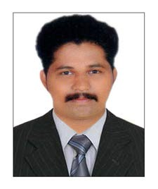
CURRICULUM VITAE

VIJITH

VIJITH.148874@2freemail.com

CAREER OBJECTIVE

PREVIOUS EXPERIENCE

PERSONAL SKILLS

ACADEMIC PROFILE

LANGUAGES KNOWN

To obtain a job within my chosen field that will challenge me and allow me use my education, skills and past experiences in a way that is mutually beneficial to both myself and my employer and allow for future growth and advancement.

INDUSIND BANK LTD, KERALA ,INDIA (one year)
Collection Agent ( Vehicle Insurance)
Job Responsibilities :-
- Initiated consumer negotiations for debt recovery through phone and mail contact
- Performed data entry level tasks for systemizing the employee information system.
- Conducted payment transactions electronically and negotiated payment arrangements for customers on their accounts.
- Responsible for contacting overdue customers and collected on historical due amount.
- Received inbound calls and answered questions from customers satisfactorily

- Excellent telephone and computer skills
- Excellent time-management skills
- Detailed oriented
- Excellent analytical and problem solving skills
- Ability to successfully multitask and be able to work with large volumes
- Demonstrated proficiency in MS Office, Excel, Word and Outlook.
- Team player.

EDUCATION | UNIVERSITY | YEAR
Bachelor Of Commerce | Kannur University | 2015
HSE Commerce | Education Board of Kerala | 2012
SSLC | Education Board of Kerala | 2010

English, Hindi And Malayalam.

Date Of Birth | 22-10-1993
Sex | Male
Nationality | Indian

PERSONAL DETAILS

VISA DETAILS

HOBBIES

DECLARATION

Visit Visa Expiry On 10th August 2017

Reading, Interacting with people and Listening Music.

The information furnished above is correct and true to the best of my knowledge.

