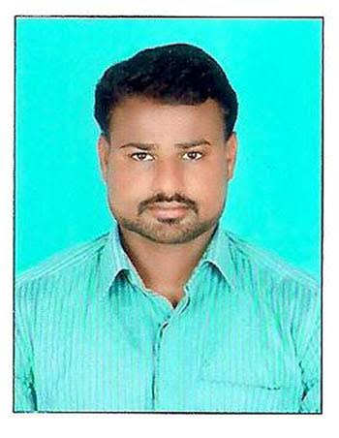
Sathish
Location : UAE, Dubai
Sathish.148884@2freemail.com

CAREEER OBJECTIVE
To secure a promising position that offers both a challenge and good opportunity for growth.
PROFILE
- Competent and experienced professional with a proven track on Administration, and Document Controller over 4 years.
- Outstanding communication and motivational abilities to facilitate attainment of strategic goals and bottom line objectives.
CAREER GRAPH

SHRIRAM TRANSPORT FINANCE CO LTD, TAMILNADU June 2010 – May 2011
Document Controller cum Administrative Asst
FASTENER POINT INDUSTRIES – UMM-AL-QUWAIN, UAE June 2011 – July 2013
Administrative Asst
SHRIRAM TRANSPORT FINANCE CO LTD, TAMILNADU Aug 2015 – June 2017
Administrative Asst
PROFESSIONAL EXPERIENCE
SHRIRAM TRANSPORT FINANCE CO LTD, TAMILNADU
- Reviewed charge documents for accuracy as well as corrected errors, return documents to source or enter missing data.
- Maintained control of input documents by properly following batch control procedures.
- Maintaining and updating all the necessary records, files, and databases.
- Receiving, sorting, distributing, and dispatching the incoming and outgoing mails and couriers.
- Maintained and compiled the records of business transactions and office activities of establishment.
- Bills, receipts, invoices, checks, policies and statements are sent after preparation.
- Other duties like book keeping, purchase supplies and payroll are also done.
FASTENER POINT INDUSTRIES LLC, UMM AL QUWAIN, DUBAI, UAE
- Provide administrative support for the department such as answering telephones, assisting visitors, and resolving and referring a range of administrative problems and inquiries.
- Maintain front desk procedures including contact information, directions and frequently requested company information
- Coordinate and perform a range of staff as well as operational support activities for the unit.
- Handled all official company correspondence efficiently
- Upgraded all office filing system
- Typed entire company documents and correspondence
- Created a systematic and reliable computerized customer database
- Responsible for training of new employees who joined the organization.

EDUCATION CREDENTIALS
Course | Name of Institution | Tenure | %
MBA (Operations) | Thanthai Hans Roever College | 2013-2015 | 62%
B.Com, (Comp.Appli.) | Thanthai Hans Roever College | 2007-2010 | 68%

PROJECTS
- A STUDY ON TOTAL QUALITY MANAGEMENT M/S PKR FASHION CLOTHES TIRUPUR

- To study the level of commitment of employees towards their work.

- To find out the factor influencing the commitment.

- Decrease of mistakes in all operation areas.

- Organizations have the certification of ISO 9000.

- Organization providing quality assurance system & Operation.

- Organizations have quality circle.

- The people are involved in quality circle.

- Organization is going for the quality audit in this company.

- This is the organization used bench marking.

- Responders practicing the 5’s Japanese philosophy.

TECHNICAL SKILLS
Operating System : DOS, Windows 98/2000/XP/2007
Package : MS Office
PERSONAL DETAILS

Father Name : Srinivasan. P
Marital Status : Unmarried
Nationality : Indian
DECLARATION
Language’s known : Tamil, English & Hindi
I hereby declare that the above said information is up to my knowledge and best of my belief.
Yours Faithfully
Date:
Place:
(SATHISH.S)

