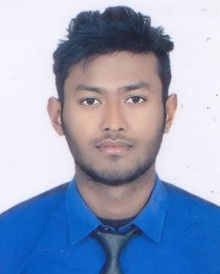
CURRICULUM VITAE

Mustaquim
Mustaquim.148901@2freemail.com

CAREER OBJECTIVE:
Take my career to a higher level, maintaining excellent work record, gaining more knowledge, skills, and experience and face the challenges of work in a multi-tasking environment and more so to contribute and associate with higher achievement.
AREA OF EXPERTISE:
Skilled at general management, Sales/Customer service, Staff motivation and training, leadership and Supervision, Visual Merchandising, loss and Prevention.
WORK EXPERIENCE:
- NESTO HYPERMARKET
POSITION : Sales Assistant
LOCATION : Buteenah,Sharjah,U.A.E
DURATION : April 14th 2016 to Till Date
- Roshni shoes centre
POSITION : Salesman
LOCATION : Dhulabari,Jhapa,M.N.P-1,Nepal
DURATION : 2012-2015
DUTIES AND RESPONSIBILITIES:
- Greeting customers who enter the shop.
- Be involved in stock control and management.
- Stocking shelves with merchandise.
- Answering queries from customers.
- Reporting discrepancies and problems to the supervisor.
- Giving advice and guidance on product selection to customers.
- Dealing with customer refunds.
- Keeping the store tidy and clean, this includes hovering and mopping.
- Responsible dealing with customer complaints.
- Working within established guidelines, particularly with brands.
- Attaching price tags to merchandise on the shop floor.
- Responsible for security within the store and being on the lookout for shoplifters and fraudulent credit cards etc.
- Receiving and storing the delivery of large amounts of stock.
- Keeping up to date with special promotions and putting up displays.
ACHIEVEMENT AND TRAINING:
- Product knowledge of the North Face, Timberland, Columbia
- Cashier training

EDUCATIONAL QUALIFICATION:
- S.L.C from East Horizon English Higher Secondary School, Mechinagar, Jhapa, Nepal
- 10+2 (Management, Accounting and Marketing) from East Horizon English Higher Secondary School, Mechinagar, Jhapa, Nepal

COMPUTER SKILLS:
- Microsoft Windows, XP, Word, Excel, Internet Access, Power Point.

PERSONAL INFORMATION:
NATIONALITY : Nepalese
PLACE OF BIRTH : Mechinagar -3, Dhulabari, Jhapa, Nepal
LANGUAGE : English, Hindi, Nepali, Bengali, Urdu
MARITAL STATUS : Single
RELIGION : Muslim

DECLARATION
I hereby declare that, the above mentioned particular are true to best of my knowledge and belief.
I Hope my qualification, skills and experiences will meet your requirement and I look forward to work with you and your organization.
………………
MUSTAQUIM

