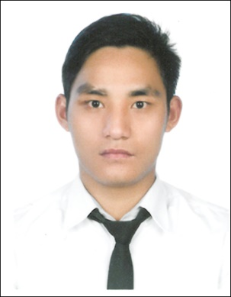
CURRICULUM VITAE

CHANDRA
Chandra.148902@2freemail.com

Dubai U.A.E

PROFESSIONAL PROFILE

To obtain a challenging job in productivity conscious workplace and perform to the limits of my potential, likewise elevate with a company recognized in its respective field or industry and contribute to the organizations success.

EDUCATIONAL A1TAINMENT

- +2 (SAHEED MULTIPUL CAMPUS )
- S.L.C (DARAI THATHI H.S.S.)

TRAINING
- COMPLETED COMPUTER COURSE AND HAVE THE KNOWLEDGE OF MS-WORD, EXCEL, POWER POINT, INTERNET SUFING AND CHATTING.
- COMPLETED FOOD HYGIENE TRAINING IN DIPOLOMATIC IN BAGMATI INSTITUTE.

WORKING EXPERIENCE
- NAME OF ORGANIZATION : NESTO HYPER MARKET SHARJHA U.A.E.
POSITION : SALESMAN
PERIOD : 2013 TO TILL NOW

- NAME OF ORGANIZATION : KATHMANDU MALL KATHMANDU, NEPAL
POSITION : SALESMAN
PERIOD : 2011 TO 2012
Duties and Responsibilities

- Proven being successful in a high pressured target-based sales environment.
- To assist and monitor item stocks and stock movement.
- Care a customer also fulfill of them desire.
- Deal to customer and listen to their queries.
- Maintain items and also care about personal hygiene.
- Inform about out of stock items.
- Check Damage Item and also remove from there.
- Focus on market sale and also about market target.
- Always think positive about customer desire.

PERSONAL INFORMATION
NATIONALITY : Nepali
TEMPORARY ADDRESS : SHARJHA – 10 U.A.E.
PREMANENT ADDRESS : PALPA, NEPAL
MARITAL STATUS : MARRIED
SEX : MALE
RELIGION : HINDU
LANGUAGES : NEPALI, HINDI AND ENGLISH
HOBBY : READING BOOKS, LISTENING MUSIC AND TRAVELING

PASSPORT AND VISA DETAILS:
VISA STATUS : RESIDENCE ( EMPLOYER)

I hereby certify that the above information mention is true and correct to the best of my knowledge and belief.

CHANDRA
Applicant

