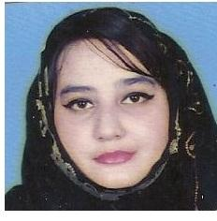
SHAZIA
Shazia.149028@2freemail.com

CAREER OBJECTIVES:

To work for a progressive organization where I will be able to use my education and experience to make valuable contribution & to achieve a challenging and growth oriented position in a professional environment where I can further develop and utilize my skills, while making a significant contribution to the organization.

FIELD OF INTEREST:

Administration
Sales
Marketing

EDUCATIONAL PROFILE:
Academic Qualifications:

Matriculation.
EXPERIENCE :

Reception Experience of 3 year
Sales lady Experience of 3 year
Marketing Experience of 4 year
Event Management Experience of 2 years

PROFESSIONAL SKILLS:

Stimulating Leadership & Team building abilities.
Creative approach to problem solving.

Strong ability to work in team and can lead the team.
Establish and maintain a professional relationship With Company.
Good verbal and communication skill

PERSONAL INFORMATION:
Name: Shazia

Gender- Female

Father’s Name: Amanullah Shah

Nationality: Pakistan - Karach

Visa Status: Visit Visa

Languages ;

.English

.Hindhi

. Urdu

. Arabic (elementary level)

REFERENCES:
Reliable & trustworthy references to be furnished upon request.

