RESUME
MUHAMMED.149120@2freemail.com
MUHAMMED
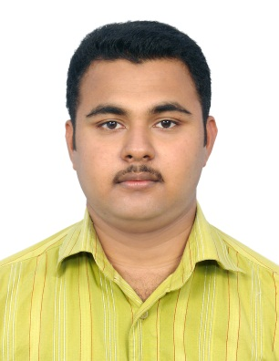

OBJECTIVE:

I would like to work for a reputed organization and to become a part of the team that strives for the firm’s goals. And to do my best in the interest of the organization, upholding its principle and priorities and working with the colleagues as a team with team spirit, determination and capabilities.

SUMMARY
- UAE license holder.
- Worked as a C store attender in Adnoc Inter National for two years.
- For the last one year worked as a Driver in Euros Electricals.
- Good analytical and communication skills.
- Likes to work in a team.
ACADAMIC PROFILE

- B.com with first class.
- Diploma in Fire And Safety Engineering from NIFE in 2008 with 67%
- Plus Two from Kerala State Higher Secondary Board, Kerala in 2006.
- SSLC from Kerala Board of Public Examinations, Kerala in 2004.

TECHNINCAL PROFILE

Operating Systems : Windows (98, 2000, XP, Vista, Windows 7), Ubuntu
Packages : MS Office.

PROFESSIONAL EXPERIENCE

- Working as Driver at Shakspear and Company, Jebal Ali for Two Years.
- Working as salesman cum driver in shakespere and company Dubai for the last two years.
- Worked as a C-store attender in ADNOC INTERNATIONAL, Adu Dhabi for three years.
- For the last one year worked as a driver in EUROS ELECTRICALS, Dubai.
PERSONAL DETAILS:

Date of Birth : 18-03-1989
Gender : Male

Marital Status : Single.
Nationality : Indian.
Religion : Muslim.
Languages Known : English, Malayalam, Hindi, and Arabic.
Visa Status : Employment Visa.
Hobbies : Driving, Playing Volleyball,
Address in U.A.E : Satwa, Dubai

DECLARATION:

I hereby declare that the above information is true to the best of my knowledge and belief.

