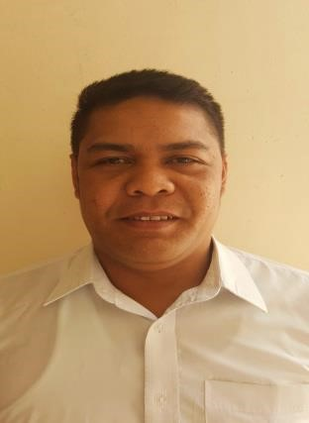
ALLAN
Over 3 years’ experience
as an Office Assistant and
Office Boy. In charge of daily tasks and maintenance. Responsible, hardworking and capable of multi-tasking. Shows commitment and understanding for the task at hand. Has great rapport and has great professional relationships with colleagues. Willing and eager to work and show my various skills in corporate setting.

- Allan.149192@2freemail.com
C/o 971505891826

Personal Details:

Visit visa

Filipino

October 24, 1980

Single

Vi

- O B J E C T I V E :

To be able to develop and share my skills in an organization and work effectively in order to attain success not only for my career but also for the company’s growth as well.

- E X P E R I E N C E :

Office Assistant/Office Boy |December 2013 – March 2017
Juma Al Majid Group: Answering telephone calls, taking and relaying messages. Maintaining and devising office systems (filing, data management).
Monitoring the use of office equipment’s, dealing with queries or requests from the visitors and employees. Assisting other administrative staff in wide range of office duties. Serving beverages to the guest and employee.

Cleaner |2010-2013
Heba Cleaning Company: Clean, stock and supply designated facility areas (dusting, sweeping, vacuuming, mopping, cleaning ceiling vents, restroom cleaning etc) Perform and document routine inspection and maintenance activities. Carry out heavy cleansing tasks and special projects.

- E D U C A T I O N :

WESTERN COLLEGE |SECONDARY
NAIC CAVITE 1993 – 1997

NAIC ELEMENTARY SCHOOL | PRIMARY
NAIC CAVITE 1987 – 1993

COMPUTER LITERATE: MS OFFICE

