RESUME

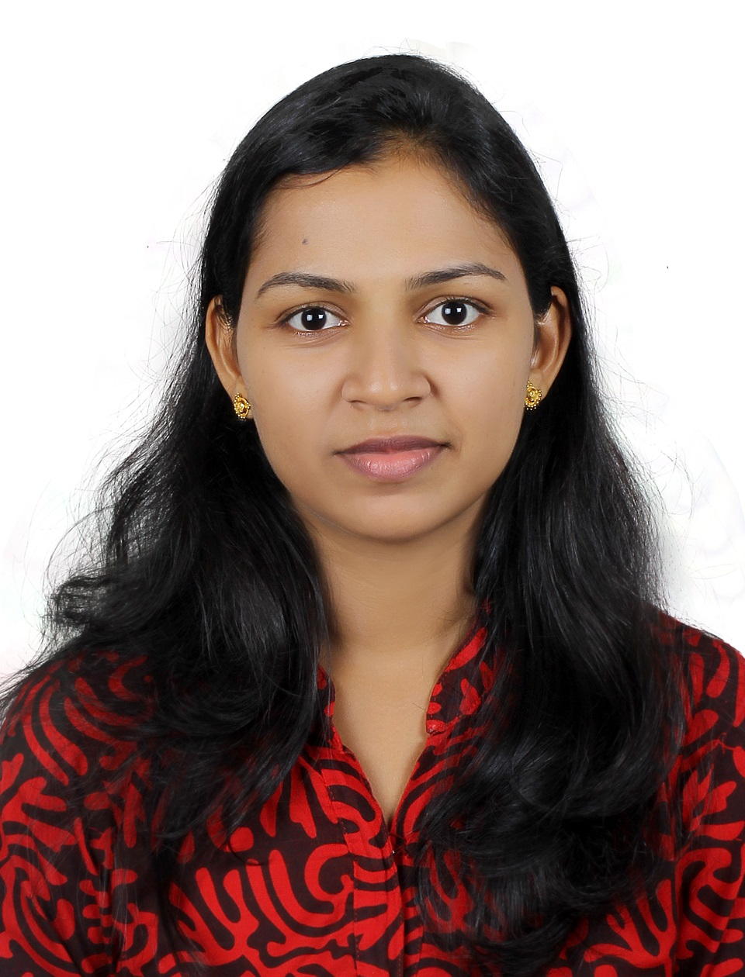
SNEH
SNEH.149202@2freemail.com

Personal Details
Date of birth : 11-05-1990
Sex : female
Nationality : Indian
Marital status : married
Visa status : Husband’s visa
Religion : Christian

Languages known
English, Hindi, Malayalam

PROFILE
F
Post Graduate in Master of Computer Applications (MCA) and Graduated in B. Sc Electronics.
OBJECTIVE

To work in a challenging and simulating environment envisage personal growth and career development by associating with an organization, which provides an ambience for learning and growth.
EDUCATIONAL QUALIFICATION
MCA (Master of computer application) | Calicut University | 2010-2013 | 65%
degree in bachelor of electronics and communication  (BSc.electronics) | Calicut University | 2007-2010 | 68%
12th Kerala State Board | Board of Higher Secondary Education Kerala | 2005-2007 | 68%

COMPUTER SKILLS

- C,CPP,JAVA
- MySQL,ASP.Net
- MS Office

Company : International Empire Traders, Deira, Dubai.
(deals with currency counting & detecting machine, Photostat machines etc.)

Designation : Admin Officer & System Operator

Job Description : Preparation of service contracts, follow-up and managing accounts for services
offered to clients varying from DEWA, Etisalat, Banks, schools, Money Exchanges.
UAE WORK EXPERIENCE 1 year Oct 2014 to Nov 2015

Key responsibilities:-

ACADEMIC PROJECT

Title : Nymble
Description : blocking misbehaving users in anonymous networks
Security system used to block misbehaving anonymous users in networks. it is
Completely a network based project. a system in which servers can “blacklist” misbehaving users, thereby blocking users without compromising their anonymity. Our system is thus agnostic to different servers’ definitions of misbehavior — servers can blacklist users for whatever reason, and the privacy of blacklisted users is maintained.

Front end : JAVA
Back end : MySQL
Sever : apache tomcat5.5

ACADEMIC SEMINAR

Presented a Seminar on “palm vein technology “a security system as a part of MCA
SOFT SKILLS
ppp
- Quick learner
- Can work as a team member as well as independently
- Pin pointed Problem Identifying skills
- Possess a flair for creative solutions
- Excellent track record in meeting strict deadlines
- Decent communication and interpersonal skills

