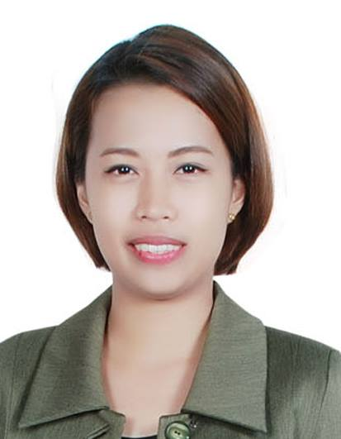
Arianne

Arianne.149283@2freemail.com

OBJECTIVE

To obtain a position in a well-established company, seek to diversify my strong organizational, problem solving, good research and planning skills.

KEY STRENGTHS

  - Excellent logical, analytical and computational skills
  - An innovative thinker, initiative taker and multi dimensional professional with exceptional logical and analytical skills
  - Strong verbal communication skills, can easily relate to other people.
  - High Quality Customer Service Oriented
  - Demonstrated interpersonal skills with the ability to establish and maintain effective working relationship with colleagues.
  - Ability to work under pressure, reliable and adaptable, can easily cope with changing positions.
  - Have knowledge in Leadership, long patience, positive attitude, tactful, hard worker, and a friendly attitude.
  - Highly motivated and able to grow positive relationship with clients and colleagues at all organizational levels
  - Willing to undergo training, enjoy new challenges, have got a strong desire to succeed and always ready and willing to learn new information and skills.

WORK EXPERIENCES

RECEPTIONIST / ADMIN ASSISTANT
April 2014 to January 2016
SONAR ELECTRONICS – Calamba, Laguna, Philippines

- Answers incoming calls and direct calls correctly. Obtains caller’s name and arranges for appointment with person called upon. Receives and communicates messages, oral and written, to and from members of the employees.
- Greet visitors and ascertain their needs and assists them with their problems or refers them to appropriate persons
- Coordinates third party delivery services for package/letter pick up for delivery
- Maintain employee records, including timesheets, sick and vacation accrual and disbursement.
- Perform the task of the dispatcher as needed.
- Type memos, correspondence, reports and other documents
- Check fax machine for incoming faxes and delivers to appropriate personnel
- Responsible for the cleanliness of the reception
- Ensure that visitors do not enter the company premises without the acknowledgement of the concerned staff.
- Ensure that no personal belongings are left by the visitors
- Responsible of establishing control of the incoming guest by issuance of identity tags and maintain proper record of the same.
- Responsible for establishing record keeping/filing systems
- Perform other Clerical duties assigned by the manager
- Ensure that incoming/outgoing documents transactions are being check for proper distribution.

SALES ASSISTANT (WORKING STUDENT)
SM Department Store
Calamba Laguna, Philippines
2011-2014

*** Job Description is available upon request…

EDUCATION

COURSE YEAR
Bachelor of Science in Business Management Major in Operation 2010-2014
STI COLLEGE

PERSONAL INFORMATION

Date of Birth : June 06, 1994
Gender : Female
Nationality : Filipino
Civil Status : Single

Other Skills : Excellent in Microsoft Office and HTML, Knowledge on Accounts and
Administrative works

I hereby certify that the above data are true and correct to the best of my knowledge and beliefs.

