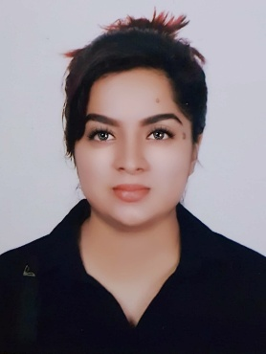 | Wathsala  Wathsala.149302@2freemail.com  Apply for: Receptionist/Coordinator/Admin. Asst/Customer care/Secretary
Profile
Personal Statement | Experienced in administrative duties: scheduled meetings, writing letters on behalf of the Director- Operations, An efficient, organized and approachable person who is always willing to help work colleagues out. Possessing fast and effective secretarial skills. Office management techniques and experience of using specialist software packages. Always happy to do the mundane office duties.  Maintaining departmental electronic and manual filing systems. Presently searching for a suitable role with an exciting and progressive company.

Academic Qualifications
Followed the BA Social Sciences degree at the Open University Sri Lanka (1st year student)

Successfully completed the Secretarial Practices Certificate level course at Ladies College Vocational Study Centre, Sri Lanka.

Passed the local Advance Level Examination in 2012  (Holy Cross College Gampaha) | English Literature : C (Credit Pass)  French : S (Simple Pass)  Logic : S (Simple Pass)

Duties
Making telephone calls and inquiries.
Writing letters on behalf of the Management.
Administrative duties like filing, updating records.
Answering emails and phone inquiries.
Preparing attendance reports.
Serve visitors by greeting, welcoming, directing and announcing them appropriately.
Perform other clerical receptionist duties such as photocopying, faxing etc.

Personal Skills
• Success and results driven.
• Excellent numeracy and IT skills.
• Research and analyze financial information.
• Proven sales and negotiation skills.
• Punctual and well presented.
• Confident outlook.
• Good listener.
• Able to work individually or in a team.
• Open minded and non-judgmental.
• Attention to detail.
• Adaptable to new situations.
• Enjoy a competitive environment.
• High energy levels.
• Able to work under pressure.
• Problem solving.

Personal
Nationality | Sri Lankan
Languages  Date of Birth  Gender | Sinhala, English, Hindi, French  19th Feb.1993  Female
Civil Status Engaged
Visa Status Visit Visa

Employment History
Receptionist – Hygiene Fresh FZE, Sharjah  Receptionist cum Secretary – Kamal Cables (Pvt) Ltd | 29th July 2016 to Oct 2016  June 2015 to January 2016 | UAE  Sri Lanka
Secretary to the Director- Operations at Link Natural Products(Pvt)Ltd. | June 2014 to March 2015. | Sri Lanka
Front Office Junior executive at Link Natural Products(Pvt)Ltd | December 2013 to June 2014 | Sri Lanka
Public Relations Officer at Hemas Hospital Wattala. | June 2013 to December 2013 | Sri Lanka

