Opportunities Looking For: Junior Positions in FINANCE / ADMIN
Career Objective:
To build a challenging and passionate career with reputed organizations where I can be a part of continual growth of the firm.
Professional Certification:
SAP from GTEC Institute, India with Grade A
(SAP ERP Navigating SAP, SAP ERP User Tips and Tricks, SAP ERP Cross- Application Time Sheet, KA for Accounts Payable, KA for Accounts Receivable, KA for Management Accounting)
Academic Credentials:
Masters of Commerce from Bharatiar University, India with 79 %
Bachelor of Commerce from Calicut University, India with 86 %
Computer, Language and Personal Skills:
Computer Proficiency: MS Office, Internet Tools and other basic
Languages Known: English, Malayalam and Tamil
Personal Skills: Effective Listening, Team building, Enthusiastic to learn, Easy adaption of new circumstances
Personal Data:
Nationality: Indian
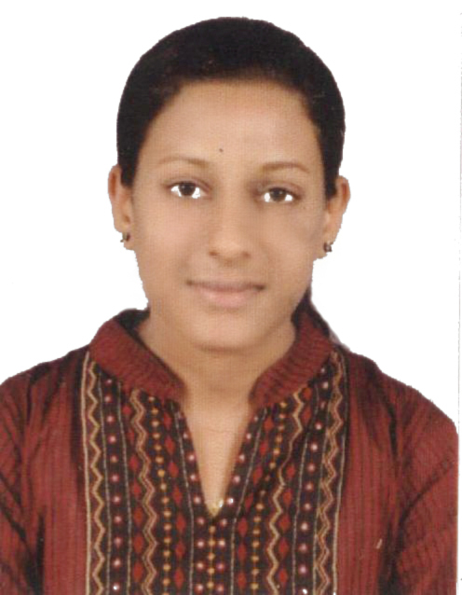
BLESSY

BLESSY.149336@2freemail.com

Present Address:
Ajman, UAE

Visa Status:
Husband’s Sponsorship

Declaration:
I hereby declare that the above stated information is correct and complete to the best of my knowledge.

