CURRICULUM VITAE
FOR
CAXTON
CAXTON.149354@2freemail.com

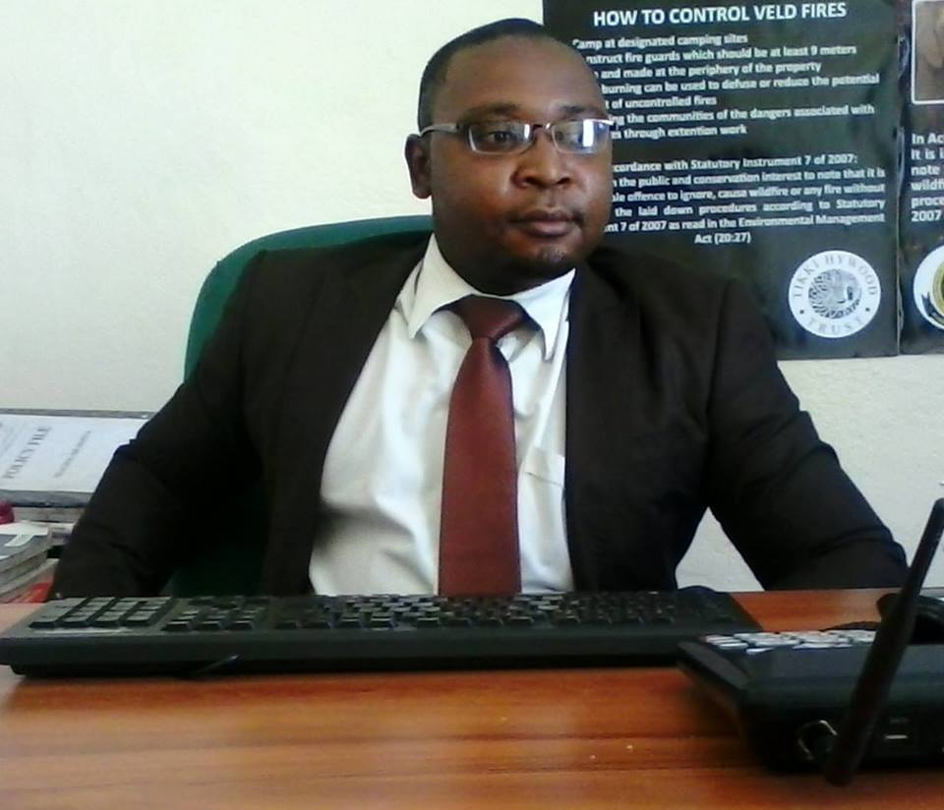

Background Summary

- Flexible, initiative and willing to learn
- Good team member
- Self-disciplined, dedicated and good in time management and meeting targets
- Able to work under pressure and inspired by challenge
- Good command in English and Shona (Local Language)
- Proficient in MS Word, Excel, Power point and Internet
- Assertive, enthusiastic and possess vision and leadership abilities to work with and achieve results through others
Ambition

- An academically goal oriented individual who would like to see himself working for an organization that help him achieve and meet the organization’s and his own vision

Academic and Professional Qualifications

Tertiary Education

- British Council Connecting Classrooms Leadership Course
Institution: British Council
Period: 2014-2014

- Executive Certificate in Project and Programme Results Based Monitoring and Evaluation
Institution: University of Zimbabwe
Period: 2011-2012

- BSc (Honours) Environmental Science and Technology:
Period: August 2004 – July 2008
Institution: Chinhoyi University of Technology
Degree Class: Upper Second Class (2.1)

Secondary Education
Advanced Level
Allan Wilson High School: (2002-2003)
3 Advanced level passes in Mathematics, Physics and Chemistry

Ordinary Level
Allan Wilson High School: (1998-2001)
9 Ordinary Level passes including Mathematics and English

Working Experience and Previous Employment Record

- Tashkent Ulugbek International School ( Uzbekistan)
Position: Science and Math Teacher
Curriculum: British
Subject Taught: Math and Science
Duration: September 2015 to Present

- Ministry of Primary and Secondary Education
School: Direct Contact Private School (Zimbabwe)
Position: Science Teacher and Campus Head
Curriculum: Cambridge
Duties
- Teaching Mathematics IGCSE syllabus 0580
- Teaching Environmental Management IGCSE and As Level syllabus 0680 and 8291 respectively
- Teaching Physics IGCSE syllabus 0625
- Development of exam Coaching Programme in preparation of June and November Cambridge Examination
- Student book inspection
- Lesson Observations
- Participation in the student and teacher disciplinary issues respectively
- Organising field trips
- Communicating with parents and carers over pupils' progress and participating in departmental meetings, parents' evenings and whole school training events
- Supervising and supporting the work of teachers
- Managing pupil behaviour in the classroom and on school premises, and applying appropriate and effective measures in cases of misbehaviour
Maintaining records of pupils' progress and development;

Achievements

- The Direct Contact School Teacher of the Year Award- Year 2013
- Teacher with 100% Award in IGCSE Environmental Management June Examinations – Year 2013
- Teacher with 100% Award in AS Level Environmental Management November Examinations and Physics IGCSE – Year 2013
- Two of my students attained the British Council Best in the World Learner Awards in Environmental Management AS Cambridge Examinations –Year 2014 and 2015 consecutively.

COMMUNITY AND VOLUNTARY WORK

- A member ofFriends of the Environment that walked from Gweru to Harare (280km), planting a 1000 trees in each city. This was in line with efforts to restorevegetation in order to combat, mitigate and adapt to climate change.
- Conducted clean up campaigns in various cities with students and corporates

Hobbies and Interests
Sports
- Watching Soccer
- Reading Newspapers

