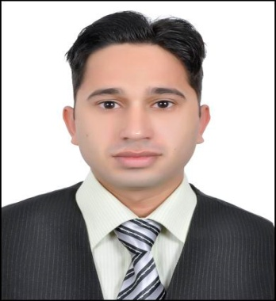
CURRRICULUM VITAE

Gulfjobseeker.com CV No: 897714
Mobile +971505905010 / +971504753686

To get contact details of this candidates
Submit request through Feedback Link
http://www.gulfjobseeker.com/feedback/submit_fb.php
Career Objective:
- An enthusiastic self motivated individual with excellent inter personal skills the ability to take responsibility & work as a team. Quality & customer focused with the drive to achieve results. To seek a challenging & responsible assignment in a reputable organization, where I apply my current skills & knowledge.

Personal Skills Profiles:
- MS Excel, MS Word, MS Power Point, Web Browsing, Report Writing, Internet and Windows. Hardware (Complete Installations)
- Digital Logical Design (DLD),Complex Variables and Transforms, Computer Aided Engineering Design (AutoCAD 2D,3D)
- Network Analysis and Synthesis, Instrumentations and Measurements, Integrated Circuits Technology, Micro Processor and Micro Controller Design, Digital Signal Processing and Ability into Perform under Pressure.
Personal Information:
- Date of birth : 21-01-1988
- Nationality : Pakistani
- Marital Status : Single
- Sex : Male
- Languages Known : English, Hindi & Urdu
- Place of Issue : Pakistan

Education Qualification:
- BE Electronics Engineering (PEC and HEC Accredited) from Hajvery University Lahore in 2007 to 2012.
- Intermediate in Pre Engineering from Federal Govt. College Mangla Cantt in 2005 to 2007.
- SSC from Army Public School Mangla Cantt in 2005.

Work Experience:
- Presently as a Security Officer in Emrill Services LLC Dubai-UAE from 2012 to till date.
- Having 4 Months Experience In Pakistan Tobacco Company (Jhelum) from 4April 2012 to 4 July 2012.
Personal Profile:
- Punctual focused an very dedicated of any task given.
- Hard working self motivating team player.
- Maintain observer’s honesty and royalty.
- To maintain good public relation.
- To maintain good relation with residence guess, new client and employers.
- To make appropriate and deteceilloy entices regarding any incident.
- Excellent planning and organization skills.

Final Year Project:
GSM Based Home Automation Security System
In this project home application like A.C, Fridge, T.V, Lights, Camera and Sensors are controlled by mobile phone. 8051 Micro Controller is used in this project.
Declaration:
I hereby certify that all the above information is true and correct to the best of my knowledge and belief.

