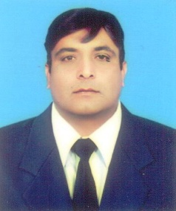
SHARIF
Sharif.149634@2freemail.com

Objective
To be an invaluable part of a dynamic organization. Where I get ample opportunities
to utilize my creative, analytical and interpersonal skills to contribute to the
Continuous success of the Organization.
Personal Information
Date of Birth:  Nationality:  Religion:  Marital Status:  Academic Qualification  Diploma Travel & Tourism Americanos College 2007-2010  Master Political Science BZ University Pakistan 1999-2001  BLIS Bachelor in Library & Information Sciences 2001-2003  B.Ed Bachelor in Education 2004-2005  Diploma in Computer Science from Jinnah College of  Professional Studied Kamalia  Skills  1 Keen sense for details Flexible and quick learner  2 Can work for long hours Can take challenges with confidence  Experience  Chakri Palace KLCC Malaysia.(Kuala Lumpur)  Ass. Manager (F&B)April 2014 to April 2017  Hilton Cyprus, Nicosia (Europe)  As a waiter 2007-08.  Captain in Restaurant & Room Service 2008 -2009.  Shift Incharge & cashment 2009 -2013.  Anassa Hotel Spa & Resorts, Polis, Cyprus.  As a Restaurant & Room Service Water (Sumer)2006 -2007.  Rocket Dinner Restaurant. (Nicosia) Cyprus.  Ass. Chef 2006 – 2007(winter)  City Café Restaurant (Nicosia) Cyprus.  As a Ass.Chef 2007-2008 (winter)  Elysium Hotel (Pafos, Cyprus)  As staff Captain in Room Service  Jun 2008 to Sep 2008  Languages Proficiency in English, Greek , Malay, Urdu & Punjabi. | 25-12-1982  Pakistani  Islam  Married

