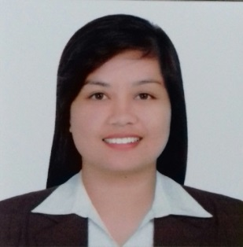

Zandra
Zandra.149660@2freemail.com

CAREER OBJECTIVE:
To engage myself in challenging and rewarding position in which I can increase my current skills and knowledge wherein there is an opportunity for my personal and professional development.

EDUCATIONAL BACKGROUND
Tertiary: Bachelor of Secondary Education
Batangas State University
Rizal Ave. Batangas City
2010 – 2014

JOB EXPERIENCE:

TLE TEACHER
St. Bridget College Alitagtag
Brgy. Dominador East, Alitagtag, Batangas Philippines
June 2015 – April 2017

Duties and Responsibilities

- Taught groups of students from various backgrounds
- Facilitated conversations with natural expressions
- Developed UBD and Kt12 learning plans
- Worked on natural pronunciation and stress patterns
- Assigned and graded assignments/performance tasks/written tests
- Experienced personal tutoring

TESDA National Certificates II
- Housekeeping NC II
- Cookery NC II
- Technical Drafting NC II

SKILLS:
- Excellent in front and Clerical Duties
- Committed, hardworking, with sense of professionalism
- Confident attitude to proactive approach to work
- Highly versatile to people, adjust easily to situation, can work under less supervision and stressful situations
- Computer Literate: Microsoft Office and the Internet
- Organization and time management skills
- Teamworking skills
- Practice occupational health and safety procedures
- Perform mensuration and calculations
- Observe procedures, specifications and manuals of instruction
- Provide secretarial support by conducting research, preparing reports, handling information requests, performing bookkeeping functions, preparing mail and scheduling conferences.

CHARACTER REFERENCES:
Available upon request.

