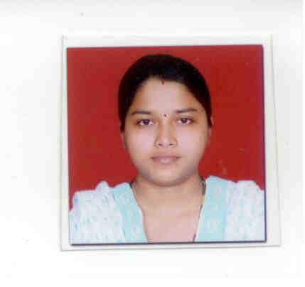
Shraddha
Shraddha.149840@2freemail.com

I had completed Masters in Computer Science from Pune University India. I worked in technical support as well as customer care executive in BPO. My Educational and work details are as follows.

Education Qualification:
Degree | University | Year of passing | Class
M.Sc ( Master in Computer Science) | Pune University-India | July 2010 | II Class
B.Sc. (Bachelor Computer Science) | Pune University-India | June 2008 | II Class
XII Std(Science) | Maharastra Board-India | Feb 2005 | II Class
X Std | Maharastra Board-India | March 2003 | Distinction

Other Qualification:
MS- Office Diploma - IT Foundation Course of COMPLIT Program by Pune University.
MS-CIT 3 months.
C Sharp dot net Course 3 Months.

Software Proficiency:
Languages Known | Java, C/C++,C Sharp.Net
Scripting Languages | Java Script, HTML,PHP
Database | PL/Pg SQL,Oracle
Operating System | Windows 98/2000/Xp, Linux

Projects:

M.Sc Project: Semester IV
A 'Online Bug Tracking System'
A Web Site; it is developed using JSP & Oracle & used to track the bugs in software products.

M.Sc Project: Semester III
A 'Multiple Mail Accessor'
A Web Site; developed to access multiple email from different sites like yahoo, hotmail etc in one mail system.

M.Sc Project: Semester II
A 'Gas Simulation Model'
A Desktop application; developed to demonstrate the basic gas laws of Thermodynamics in visual way to understand easily.

M.Sc Project: Semester I
A 'Gui Code Generator'
A Desktop application, which is developed to ignore tedious work for form designing & coding using Java. A user can select a component and view the source code in java language.

Ty.B.Sc Project:
A Web Site by the name ‘On-Line Recipe Website’
It’s designed as a website maintained by an individual. It provides accessibility of various types of recipes on the internet platform and on computers using JSP features.

Work Experience:
Customer Care Executive and for Technical support in Tata Business services solutions India.

PERSONAL DETAILS:
- Date of Birth : February 7, 1988.
- Gender : Female.
- Languages Known : English and Hindi
- Visa Details : Husband Visa ( Residence 2 Yrs )

I hereby declare that above information is correct to the best of my knowledge and belief.

Place: Sharjah.

