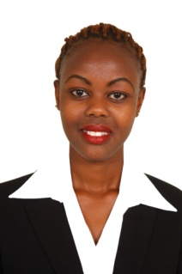
CURRICULUM VITAE
Mary.149890@2freemail.com

Name : Mary

AREAS OF SPECIALIZATION: Hospitality Management

PERSONAL PROFILE
- I have the ability to learn quickly and achieve the required target set by the organization
- Positive efficient and proactive with excellent knowledge of guest service
- Manage myself in all best owned position to reach my goals
- Principled to work under minimum supervision
- Flexible, self confidence, social, good communicator and passionate in all I do.

OBJECTIVE
- To work with professionals who are goal oriented in atmosphere of team spirit
- To work in a dynamic organization full of challenges
- To be trained and exposed in depth potentials.

JOB EXPERIENCE
January2016 -May 2017 : Chrislewis Restaurant
Waitress

June 2015 - Dec. 2015 : Sagret Hotel Milimani
Waitress

March - June 2015 : Hilton Hotel Nairobi
Food And Beverage Training

Responsibilities
- Attract, welcome and serve guests to their comfort and answer questions and suggest other information on our product service
- Resolve product or service problem by clarifying the customers complain, determining the cause of the problems.
- Selecting and explaining the best solution to solve the problems expediting correction: following up to ensure resolution
- Maintained financial accounts
- Recommend potential products and services to management by collecting customer information and analyzing customer needs.
- Contribute to team effort by accomplishing related results as needed.

EDUCATION BACKGROUND
2013 – 2014: Nairobi Institute of Business Studies
Diploma in Hospitality Management

2008 – 2011: Muthiga high School
Kenya Certificate of Secondary Education

1998 – 2007: Karure Primary School
Kenya Certificate of Primary Education

LANGUAGES
Fluent in English & Kiswahili
Conversant in Spanish

REFEREES
Available upon request

