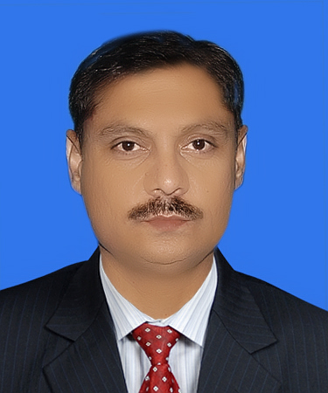
Nasir
Nasir.150120@2freemail.com

\

Professional Objective :

Seeking job with a progressive Organization to pursue a long-term career.

Skills

Responsible.
Strategic thinking.
Ability to work in a group / team.

Ability to work in challenging situations.
Financial & Auditing skills.
Accounting skills.
Educational Attainments
MBA –Finance: West Coast Institute of Management
& Technology-Clifton campus Karachi .

Bachelors of Commerce : Karachi University.
Higher Secondary School : Government Premier College-Karachi .

Professional Experience
Essa Engineering Industries (Private) Ltd - (Oct 2014 to June 2017)
(Manufacturers & Exporter of Quality Automotive Filters)

( Manager Finance & Accounts-(Reporting to Directors)
Responsible for:

- Supervision of preparation of final accounts for external audit purpose
- Supervise of preparation of monthly Profit & Loss statements.
- Review of bank reconciliations of all bank accounts.
- Supervision of Customer & Supplier Billing.
- Supervision of Receivables & Payables summaries which includes Weekly, Bimonthly & Monthly.
- Supervision of Statement of account reconciliation with parties.
- Follow up for recoveries.
- Monitoring of credit limits and live balances of customers.
- Monitoring & analyzing department work to optimize maintaining a high level of accuracy.
- Monitor Import & Export of Company (including all necessary documentation)
- Check & Ensure Annex statements of e-filling of tax authorities (FBR).
- Ensure Sales Tax & Withholding tax figures before filling return.
- Monitor & finalize Income tax & Sales Tax Audits.
- Check & Ensure WPPF, EOBI & SESSI working.

Max Zealer Cosmetics (Private) Ltd ( Jan 2008 – Sept 2014)

(Manufacturer, Import & Export of Color & Skin Cosmetics)

Senior Accountant-(Reporting to General Manager)
Responsible for:

- Prepare Final Accounts of company on Monthly, Quarterly and Annual basis.
- Monitoring financial system for recommendation, improvement & coordinate profit plan process.
- Planning & execute of all accounting functions & ensure accurate & timely reporting & analysis of data.
- Checking of accounts books, voucher and daily working report.
- Prepare Cash Flow Statement.
- Arrange & supervise funds from banks for company payments.
- Supervise & Conduct Internal & External audit.
- Review & Prepare monthly report regarding activities of cash & banking section.
- Costing of Company Products..
- Monitor & check Supplier Income Tax on according Payments schedule.

Max Zealer Cosmetics (Private) Ltd – ( July 2004 - Dec 2007)
(Manufacturer, Import & Export of Color & Skin Cosmetics)

Accountant-(Reporting to Senior Accountant)
Responsible for:
- Prepare, manage and organized all books, records keeping.
- Invoice Management and necessary follow ups.
- Generate Daily business reports.
- Data entry of all business transactions and ensure necessary documentation
- Assist in e-filling of tax withholding statements & maintain petty cash account.
- Maintain proper financial record and filling system according to organization
requirements.

Osmani & Company (Private) Ltd -- ( Jan 1999 - Feb 2002 )

(Importer & Distributer of Uni-Lever Pakistan Ltd).

Accounts Executive-(Reporting to Directors)
Responsible for:

- Prepare & Maintain Account books (i.e general ledger, cash book, debtors, creditors and sales register.
- Managing tax related activities (Income Tax return & Sales Tax Return)
- Arrange the fund transfer in banks for payments of Suppliers, Utility Bills and salaries as and when needed.
- Supervising the process of daily postings of collection from Distributors.
- Reconcile & control Banks.
- Coordination with external Auditors for Annual audit
- Working & Co-Ordinate with Tax consultant of company Sales Tax & Income Tax Matter .

December 1994 – November 1998
Article-Ship (Completed Four Years)
Feroze Sharif Tariq & Co. (Chartered Accountants)

During Audit Training
- Helping in planning of audit of various clients and developing planning memorandum;
- Checking Clients books of Accounts in accordance with the Companies Ordinance, 1984 and applicable International Accounting Standards;
- Conducting the audit in accordance with the International Standards of Auditing and local Tax Laws respectively; &

- Finalizing of various jobs including multinational and Public Limited Companies.

Computer Literacy
- Proficient in all components of Microsoft Office.

- Accounting Software.

- Internet and Emails.

- Visa Status : Visit Visa
Achievements
- Appreciation Certificate at Annual Conference 2009.
- Appreciation Certificate at Annual Conference 2008.
- Achieve Best Officer of the Year at Annual Conference 2004.
Other Skills
- Participate on Workshop held for developing specialized skills against Withholding Taxes under Income & sales Tax Laws in 2015.
- Participate on Workshop held by SMEDA (Ministry of Industries & Production Government of Pakistan) against Sales Tax Return filing in 2016.

Reference submitted (If necessary) according to requirement) .

