Islom
Islom.150246@2freemail.com

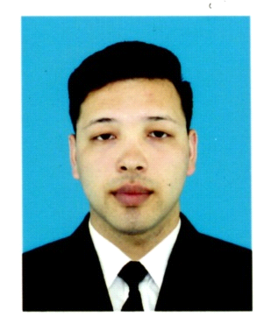  Job Objectives  To bring to your organization enthusiasm, dedication, responsibility, and good work ethic, combined with a desire to utilize my skills obtained through experience. To obtain a position that will enable me to use my strong organizational skills, educational background, and ability to work well with people  Relevant Skills  - Excellent Sales ability  - Identify and solve customer needs  - Strong communication and organizational skills  - Positive attitude and Team player  - Highly-motivated person and hardworking.  - Computer literate (knowledge in MS Word, MS Excel, MS Power Point,Internet)  Date of Birth  02 October 1995  Marital Status  Single  Nationality  Kyrgyzstan  Fluently Speaks  English/ Russian  Turkish/ Kyrgyz/ Uzbek  Visa Status  Tourist Visa  Area of Interest  Boxing And wrestling |  | I am an enthusiastic person, who enjoys being part of leading,successful and productive team. I am quick to grasp new ideas and concepts, and to develop innovative and creative solutions to problems. I am able to work well on my own initiative and can demonstrate the high levels of motivation required to meet the tightest of deadlines. Even under significant pressure, I possess a strong ability to perform effectively.  Work Experiences  Waiter  Restaurant Korchma Taras Bulba Russia, Moscow  April 2016-2017 March  Duties And Responsibilities.  - Welcome customers as they arrive and ask for seating preferences  - Seat customers and offer drinks and menu  - Take food and beverage orders and communicate to the kitchen through POS system  - Deliver orders to the table in a timely manner  - Ensure quantity, quality and accuracy of order  - Clean tables and ensure that they are bussed appropriately  - Effectively set up tables, and prepare and serve food and beverages according to set instructions.  A cook  Restaurant Korchma Taras Bulba Russia, Moscow  November 2014–June 2016  Duties And Responsibilities.  - Set up and cleaned equipment for daily food preparation  - Cut trimmed and boned meats, cleaned and prepared vegetables and fruits  - Assembled and accurately measured ingredients  - In-depth knowledge of food  - Dealing with costumers, good explanation about the products promptly solving the inconveniences and discrepancies;  - Multitasking ability to handle multiple tickets  - Able to adhere to precise instructions of the head chef  Sales Executive  Brands MIX, Osh, Kyrgyzstan, 2013 - 2014  Duties and Responsibilities:  - Greeting customer as soon as walk into store.  - Identifying customer needs by listening with empathy, acknowledging the required needs and giving excellent customer service.  - Creating customer data base - Follow up on customer’s request and update on new collection.  - Making sure display lay out up to the standard.  - Looking after stock room layout tidiness and neatness.  - Dealing with cash float – counting the transaction amount accurately. Performing tasks such as counting money, separating charge slips, balancing cash drawers, and making deposits.  - Help customers try on merchandise.  - Clean shelves, counters, and tables.  - Maintaining all relevant records and documents.  - Have a thorough understanding of the value and cut of certain types of garments and gift products.  Education  Osh Kyrgyz-Uzbek University, Faculty of Economy, Kyrgyzstan, 2012-2017  Personal Features  - Strength: fast moving person, honest and excellent on customer service.  - Gets along with co-workers and works with a team.  - Adopts well with modern technologies.  - Willing to go overtime in order to meet deadlines or finish projects ahead of schedules.

