COVER LETTER

JOYDEEP
JOYDEEP.150267@2freemail.com

Respected HR Team,
Greet for the day,
Let me introduce myself as Joydeep as I am forwarding my cover letter along with my Resume for your kind consideration. Well, I am pursuing Post Graduate Diploma in Business Administration from Symbiosis Centre for Distance Learning, Pune. I have done my Graduation in Bachelor of Business Administration from WBUT, Kolkata.
Presently working with World Wide Safety Pvt. Ltd. as Office Administrator Assistant. It’s been 3 years I am working with this company.
Now I am looking for a more challenging field where I can show my skills and knowledge where I can improve myself more so that where I will be able to gain more knowledge’s experiences as well ,which will help me in future too. I can assure you that if I will get chance to prove myself I will give 100% to this company with my best abilities, dedication and sincerity. I am responsible at my work to coordinate with the entire department to support them.
So it’s my humble request to you to go through my Cover Letter with attached resume. I will be grateful if I get an opportunity. Thank you and looking forward for your favorable reply.

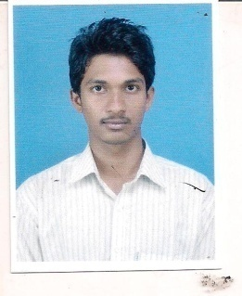
CURRICULAM VITAE

JOYDEEP

PROFILE SUMMARY

- A competent professional with experience in Office Administration.
- Capable of adopting new measures and understanding the changed circumstances for fast adaptability & ensuring implementation in the organization for its benefit.
- Skill in maintaining records & writing the minutes of meeting with upper level officers.
- An effective communicator with excellent interpersonal, analytical & relationship management skills.

ACADEMIC QUALIFICATIONS

EXAM/DEGREE | YEAR OF PASSING | NAME OF INSTITUTE /BOARD | PERCENTAGE
Bachelor of Business Administration | 2013 | Dinabandhu Andrews Institute of Technology and Management | 55
XII | 2010 | W.B.C.H.S.E | 69
X | 2008 | W.B.B.S.E | 63

WORK EXPERIENCE

Presently working with Office Administrator Assistant in World Wide Safety Pvt.Ltd. from 14th of April 2014
TOTAL EXPERIENCE: -- 3 years 4 months
RELIVENT EXPERIENCE :-3 years 4 months
JOB LOCATION: - Kolkata

COMPUTER EXPOSER

- Knowledge with Microsoft Office Kit- MS Excel, MS Word , Power Point

MEMBERSHIP
- Team Spirit & adaptability.
- Better Time Management.
- Self-Discipline, Commitment.

PERSONAL PROFILE

Date of Birth : 17th October, 1993
Languages Known: English, Hindi and Bengali
Nationality: Indian. SEX: Male. Marital Status: Unmarried

