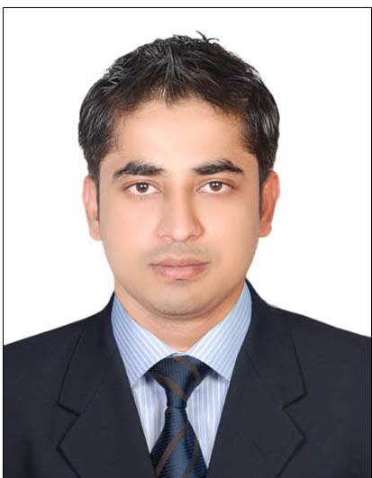
CURRICULUM VITAE

Contact Details
Name : MOHAMMAD IMRAN
Email : Imran.150399@2freemail.com

CAREER OBJECTIVE:
More than 6 year of working experience as a F&B Service. Looking forward for a position in the firm to provide me a
platform where I can showcase my talent and responsibility towards increasing company’s day to day activities and
performance.

Employment History
April 2014 to Present: Park Regis Kris kin Hotel ,Dubai work as a Captain In Room Dining.
Responsibilities and duties:
1. Responsible for guiding the hostess, waiter/waitress and bus boy/girls in the performance of their jobs.
2. Responsible for ensuring sufficient operating guest supplies, beverage supplies and operating equipment
during outlet’s operation.
3. Responsible for the over all sanitation and cleanliness of the outlet during the shift.
4. Responsible for the proper maintenance and good working order of all equipment, furniture and
fixtures in the outlet.
5. Responsible for consistently implementing the service standards and operating procedures in the
outlet.
6. Responsible for ensuring sufficiency of manpower in the shift.
7. Performs other duties and responsibilities assigned by immediate superior, which leads to guest
satisfaction and profit for the hotel.

SEPT 2011 – Mar 2014: Koyla Lounge Restaurant & Café, Dubai.
Responsibilities and duties:
- To greet the guests in professional manner.
- To escort the guests to the table.
- To present the menu to the guest and assist them through the menu.
- To take the orders, place through the system (Alta vista) and delivering them according to the standard policy.
- To prepare and present the guest check.
- To up sell the new products launched in-house to the guests.
- To maintain the cleanliness of work area at all times.

MAR 2010 – Feb 2011: Room Service & Food & Beverage Department, Ticlo Resort– Goa India.
Responsibilities and duties:
- To understand and respond to all guest needs and request in timely and professional manner.
- To follow specified procedure to provide prompt, efficient and gracious service to the guest in their rooms.
- Answering departmental calls, taking and delivering order and preparing and presenting guest check.
- To maintain hotel corridors free of used room service items at all times.
- To maintain the cleanliness and safety of work areas at all times.
- To up sell the hotel products to the guest in the rooms.

Skills
• Outstanding customer service skills
• Excellent written and verbal communication skills
• Good attention to detail
• Ability to follow instructions and fulfill orders rapidly
• Enjoy working in a team environment
• Dependable and reliable – Able to work efficiently without supervision

Educational Qualification: Higher Secondary Certificate Maharashtra College in 2009.

Additional Training & Qualification

Basic Food Hygiene Training in Park Regis Hotel, Kris kin/Dubai

Attended H.A.C.C.P. training in park Regis Kris kin hotel Dubai

Had a success full Fire fighting Training.

Attended training basic food hygiene by Park Regis hotel

Had success full communication skill training by park Regis Hotel Dubai.

Other Skills
Computer skills:
- MS Word, MS Excel, Ms Power point etc.
Language known:
- English, Hindi, Urdu

Personal Details

Date of birth : 10 DEC 1988
Citizenship : Indian.
Visa Status : Employment.
Gender : Male.
Marital Status : Single.

