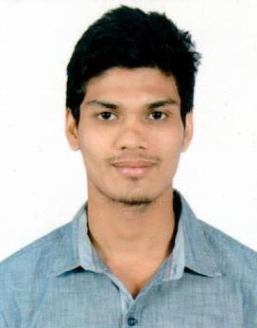

Curriculum Vitae

**Yashank**

[**Yashank.151050@2freemail.com**](mailto:Yashank.151050@2freemail.com)

**PERSONAL DETAILS:**

Date of Birth: 2nd Dec, 1994

Gender : Male

Nationality: Indian

Marital Status: Single

Visa Status: Visit Visa

**LANGUAGES KNOWN**

English, Hindi and Gujarati

**HOBBIES**

Music, Travelling, Bike Riding

**PERSONAL ATTRIBUTES**

* Initiative, Learner, Smart Working, Creative and a team worker
* Diligent, committed and responsible
* Confident, co-operative
* Stimulated by challenges and result oriented
* Enthusiastic and friendly

**STRENGTHS**

* Good verbal and written communication and presentation skills.
* Hard working abilities.
* Teamwork.
* Computer ability.

**COMPUTER PROFICIENCY**

* Basics in computer
* MS Office (Word, Excel, PowerPoint)
* Internet surfing.
* All basics software and hardware.



**CAREER OBJECTIVE:**

To pursue a career that enables me to achieve a responsible position that helps me apply, refine and revive my knowledge and analytical abilities on an ongoing basis which in turn will assist me to develop and grow with the organization.

**EXPERIENCE:**

* I had an experience of 1 year in INDIAN INCROP.LTD.PVT (Admin Back Support Reliance I-care)
* I am working with “Reliance” form last 2 year in Backhand department.
* Worked with Transcend International as Customer Support Officer for 9 months.

**ACADEMIC QUALIFICATION**

* **I.A.N.T** 2013
* **Diploma in E.C Eng.** 2012

(Electronic and Communication)

Gujarat Technology University

* **S.S.C. Examination** 2010

G.S.E. Board, Gandhinagar

**MAJOR MODULES STUDIED UNDER CURRICULUM:**

* Comptia Strata
* E-C counselling
* MS. Office
* CSCU

**DECLARATION**

I hereby declare that the above-mentioned information is correct and true as per my knowledge.