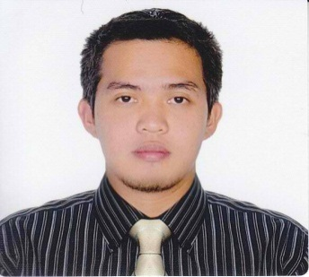
Gulfjobseeker.com CV No: 918156
Mobile +971505905010 / +971504753686

To get contact details of this candidates
Submit request through Feedback Link
http://www.gulfjobseeker.com/feedback/submit_fb.php

CAREER OBJECTIVE

To contribute to the growth and development of an esteemed institution vis-à-vis my professional and personal growth

PROFESSIONAL PROFILE

Technical professional with solid and hands on working history in the field of telecommunications. Has substantial background and experience in Network Quality Management. With proven ability to work under pressure, can work under minimum supervision, good communication and problem-solving skills.

PROFESSIONAL EXPERIENCE

Designation TELECOMMUNICATIONS ENGINEER
Date September 2008-April 2012
Company Name Smart Communications Philippines Inc.
Company Industry Telecommunications
Address Makati City, Philippines

Work Description Hired as 2G/3G RF Optimization engineer to handle optimization, KPI/performance monitoring and troubleshooting of a certain cluster in South Luzon Region. Performs Cluster Optimization through drivetest, parameter changes, site audit,
Antenna reorientation and tilting and frequency planning of the area to ensure
KPI’s are exceeded and enhance subscriber experience. Conducts worst cell troubleshooting and coordinates with different technical counterparts to ensure quality of service is provided. Responsible for the improvement on signal coverage, quality and site performance of the cluster. Handles events and festival preparations which includes planning, pre/post optimization and functionality tests for the area. Handles technical support for customer concerns and inquiries.

Designation BUSINESS PROCESSING ANALYST
Date March 2007 – August 2008
Company Name Manulife Business Processing
Company Industry Insurance
Address Quezon City Philippines

Work Description Hired as Business Processing Analyst to ensure retirement claims of clients are properly processed and correct payment was released. Also performs quality checking of processed claims of colleagues locally and abroad to ensure quality of service.

Designation MEDICAL CLAIMS – QUALITY ANALYST
Date February 2006 - March 2007
Company Name Accenture Philippines
Company Industry BPO
Address Mandaluyong City, Philippines

Work Description Hired as Quality Analyst that performs quality checking of processed medical claims. Coordinates with counterparts abroad to ensure quality of service is provided to the customers.

TECHNICAL SKILLS

Hardware Agilent/TEMS Drivest Equipment, Protocol Analyzer,
Site Audit Tools

Software MS Office, Actix Post Processing Tool, Mapinfo, Google Earth,
NSN Platforms: Application Launcher, Netact Plan Editor, WCDMA BTS/AXC Manager Reflection, NETACT (Reporting Suite, Configuration Manager).
HUAWEI Platform: M2000, LMT
ERICSSON Platform: ENIQ, Citrix, Business Objects

EDUCATION, CERTIFICATION & AFFILIATIONS

Bachelor of Science major in Electronics and Communication Engineering
Ateneo de Naga University, Philippines (June 2000 - March 2005)

Licensed Electronics Engineer, Registration No. 0036514, November 2005, Philippines
Member, Institute of Electronics Engineers of the Philippines
Member/Choreographer, University Dance Club, Ateneo de Naga University, Philippines
Member, Gabay Scholars, Ateneo de Naga University

PERSONAL INFORMATION

Nationality : Filipino
Gender : Male
Date of Birth : 14 June 1983
Marital Status : Single

