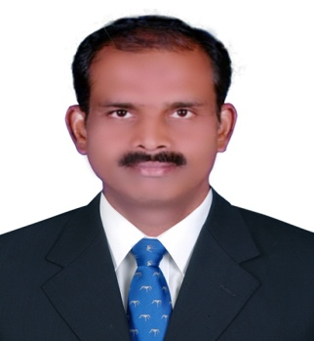
Uday
Uday.155643@2freemail.com

Objective :

To achieve a challenging position in an organization by being a part of a dynamic and
challenging work group and contribute to the growth of the firm.

Educational Qualification :

Diploma in Electrical Engineering from C.P.C Polytechnic, Mysore in the year 1987.
Professional Experience :

1. Supervisor : From Sept 2010 to Nov. 2012.
Employer : Dalkia India Pvt Ltd..,
Site Location : RMZ group,Belandur,Bangalore..

2 Supervisor: From Oct. 2008 to Nov.2009.
Employer : Apollo power Systems.,
Site Location : Honeywell,Bannergatta Road,Bangalore.

3. Senior Technician : From Sept 2005 to Apr-2007.
Employer : Sodexho Pass Facility Management Services (P) Ltd.,
Site Location : Wipro Technologies, Electronic City, Bangalore
.
.4.Supervisor: From Jan 2003 to Aug 2005.
Employer : Tyco Engineering Infotech Services (P) Ltd., Bangalore

5. Maintenance Engineer : From Jan 1992 to Aug 1997
Employer : The Indian Hume Pipe Co. Ltd., Pune.

6. Testing Engineer : From Jan 1989 to Dec 1991
Employer : Universal Transformer (P) Ltd., Bangalore.

Nature of Working Experience :

I have experience in operation, maintenance and trouble shooting in the following
M&E equipments.

1. D.G. sets ranging from 320KVA to 1500KVA (Cummins make engines)

2. Chiller plants (Both Air & Water cooled) ranging from 60TR to 380TR capacity (Carrier make).

3. U.P.S. Ranging from 40KVA to 300KVA capacity (APC, Emerson Liebert, MGE make).

4. HT & LT Panels, Transformers of 630 KVA to 2000KVA.

5. Working procedure of DOL & Star Delta Starters & Induction motors

Responsibilities :

I have been handling the following Responsibilities successfully.

1. Scheduling & Completing of preventive maintenance activities of M&E.

2. Preparing checklists, logsheets for M&E equipments.

3. Preparation & submission of daily & monthly reports, B&D forms.

4. Preparing & Maintaining breakdown service reports & complaint registor.

5. Co-ordination with the vendors for servicing of equipments & completion of snag list.

6. Planning & execution of work from electrician, A/c technician, plumbers & carpenters.

7. Co-ordination with the clients for purchase of materials modification works & other
servicing works.

