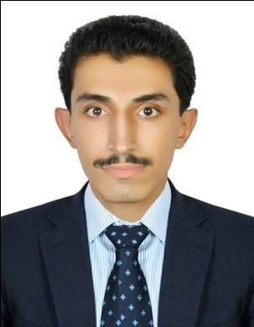

Nasir

Nasir.158258@2freemail.com

OBJECTIVES:
To utilize my skills and abilities in the field of Administration that offers great learning opportunities and challenges beside professional growth while being resourceful, innovative and flexible and be able to contribute in the advancement of the company whom I will be working for.
EXPERIENCES:
(April 2011 – April 2014) Company Al-Shaya, Shop Evans (Jeddah KSA)
Sales Executive
- Selling and promoting all types of ladies’ wear.
- To ensure satisfying customer service.
- Maintaining the availability of the stock in order to sustain the customer demands.
- Complete proper checking of the stocks with barcodes before to sale products.
- Updating of promotion and discounts with the corresponding details and information.
(July 2014 – January 2016) Akbar Garments (Jeddah KSA)
Sales Executive
- To sale ladie’s imitation jewelry followed by barcodes in system.
- To sale ladie’s wear followed by barcodes in system.
- To sale men’s wear followed by barcodes in system.
- Handling and giving customer service via phone calls.
- Giving proper attention when sales promotions being on without timeframe.
(March 2016 – June 2016) MoneyGram (Jeddah, KSA)
Sales promoter
- To sale MoneyGram promotional cards which has exclusive offers based on nationalities.
- Creating to implement the ideas of sales of promoting a product.
- Looking for sales stability in order achieve the daily targets.
- Handling and giving customer service via phone calls.
EDUCATIONAL ATTAINMENT:
2013 – 2015 Pakistan International School
Jeddah, Saudi Arabia
Matriculation in Arts Education
COMPUTER SKILLS:
Microsoft Office (excel, word, PowerPoint)
LANGUAGE SPOKEN:
English
Urdu
Hindi
Pashto
PERSONAL INFORMATION:
Father’s Name : Amir Hussain
Gender : Male
Nationality : Pakistani
Marital Status : Single
Age : 20
Visa Status : Visit
Visa Expiry : 11 october

