Rosita.158264@2freemail.com

CURRICULUM VITAE

ROSITA E. DABALOS BS COMMERCE MAJOR IN BANKING AND FINANCE
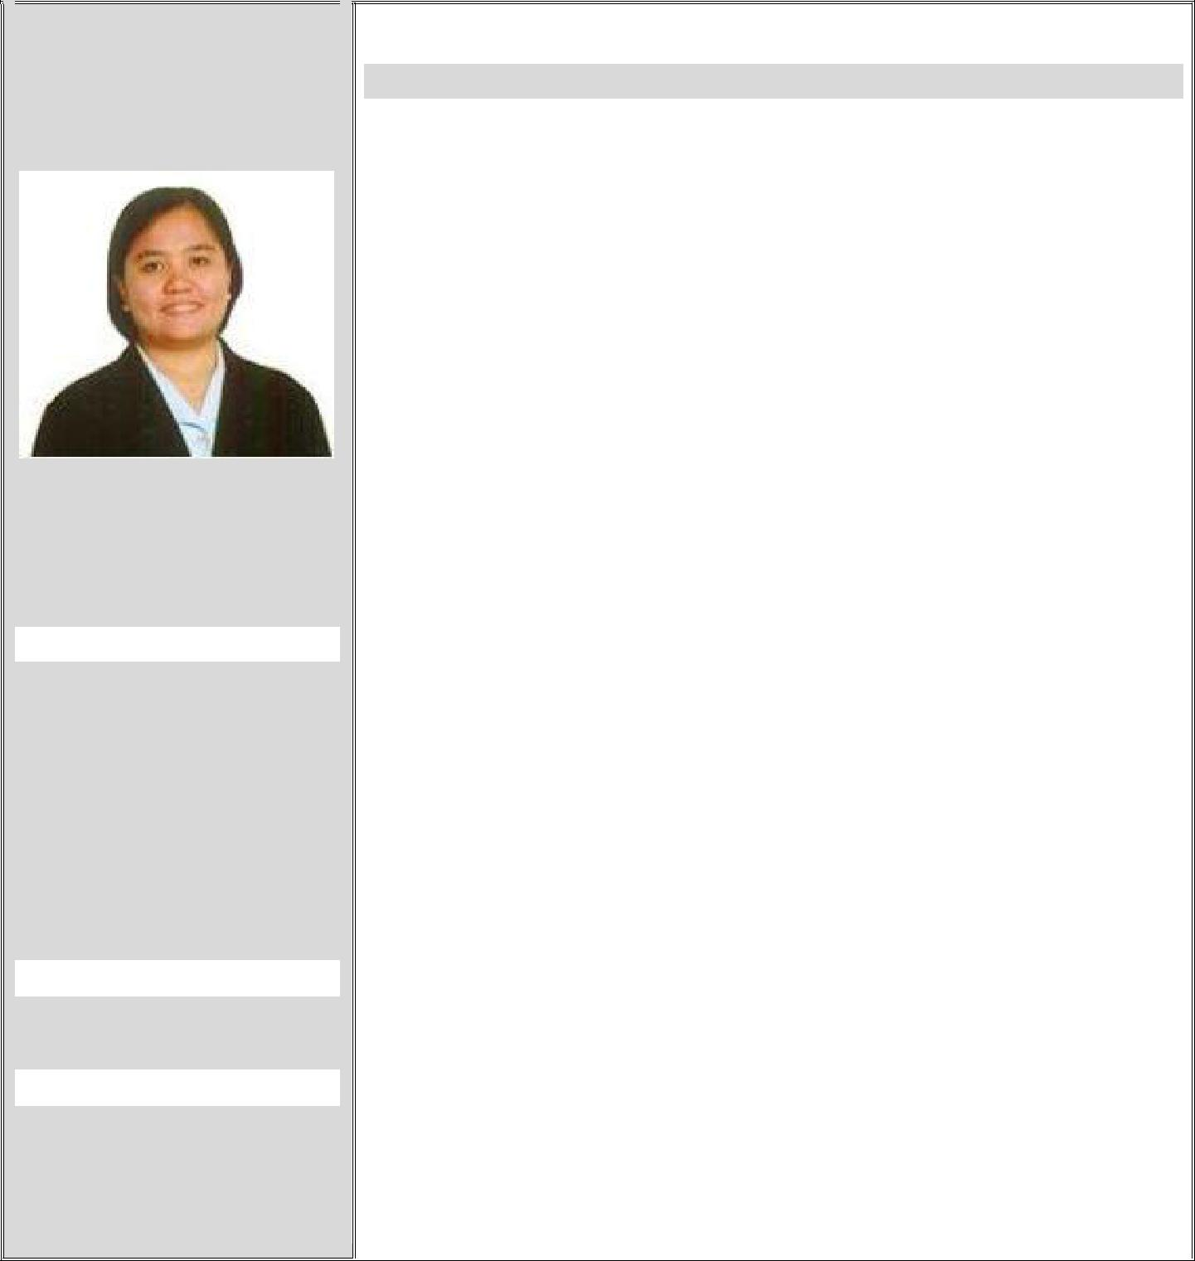

PERSONAL PROFILE:

Email:

Contact:

PERSONAL DATA:

Gender: Female Religion: Roman Catholic Marital Status: Single Nationality: Filipino Passport No: Status of Visa:

Tourist/Visit Visa Location: Dubai City

Career objective:

- To support the growth and profitability of an organization that provides challenge, encourages advancement, and rewards achievement as well as provide opportunity to utilize my substantial experience, skills, and proven abilities in any managerial/supervisorial setting.

QUALIFICATION:

- BACHELOR OF SCIENCE IN COMMERCE MAJOR IN BANKING & FINANCE

 | PROFESSIONAL EXPERIENCE: |  | IT PROJECT MANAGER
 |  |  | (September 2015- 2016)
 |  |  | GLOBE TELECOOMUNICATION, PHILIPPINES

Overall responsibility is to ensure successful execution of the project design by effective planning, organizing, leading and controlling its parameters to achieve the project objectives (compliance with standard specifications, within budget allocation and timely completion). These parameters include well-define project schedule, effective tools for measuring the progress, evaluating deviations from plan, equipping corrective actions, identifying the organizational structure of the project team ,setting team direction and coordinating activities across different organizational functions and collaboration with the external services, stakeholders.

Specific duties and responsibilities:

- Ensure completion of projects within the estimated target date and budget preferably incurring savings

- Coordinate the project progress to the stakeholders on a timely fashion manner

- Proactive participation in team motivation and facilitate

LANGUAGES KNOWN: VISAYAN, TAGALOG, ENGLISH

DRIVING LICENSE: Issued at: PHILIPPINES License No: N01-16-030226

PERSONAL STRENGTH:

- Good Communication & Coordination Skills

- Smart Working

- Good Understanding Ability

- Easily Adaptive

- Ability to Deal with People Diplomatically

- Ability to work individually and closely with others to accomplished assigned goals

PERSONAL INTEREST:

- Playing Musical Instrument ( Guitar, Piano, Organ and Drum)

- Playing Volleyball

- Computer Browsing

REFERENCES:
As required

conflict resolution to drive improvement

- Hand in hand working with Business Analyst to extract, anticipate, constraint, organize, translate, safeguard, simplify, verify, managing requirements and system and operation maintenance.

- Handling 4 Projects of the following:
  - LAN cabling & Network Telecom set up in
Coordination with the technical SME’s
  - Risk & Vulnerability Management

  - Queuing System for every Branches at Globe Telecom

  - Banking Integration System Process ( Credit Card, Queue Machines, Auto Debit Card)

  - Web, Cloud, Call & text promos both pre-paid and post paid account in coordination with the platform owners and technical SME of DBA and Network team

  - Managing you tube, Google account/project in coordination of Google technical team from US and Singapore.

- Identify stakeholders of the project and understand customer needs and business objectives

- Recommend technical resolutions from deviations of the plan by tedious evaluation of the process.

- Be able to lead project and systems integration work with project team members
- Risk identification and mitigation

- Escalation and change management
- Communicate and document key program requirements, policies and procedure and status to clients, internal team members and other key stakeholders including an executive audience

- Track, manage and assess hours and expenses for project resources to ensure accuracy and the project is
within budget guidelines

IMPLIMENTATION PROJECT MANAGER (September 2012- August 2015)
Intellismart Technology Inc., PHILLIPINES

- Coordinating & Communicating project management scope

- Handles issues that may arise during the project and address them to clients
- Over seeing project development & Team
- Responsible in implementing the project within the allocated schedule and budget

- Timekeeping Process & Procedure Module

EDUCATIONAL
BACKGROUND:
B COM Major in Banking

- Finance- Christ the King College, Philippines

COMPUTER KNOWLEDGE/ TECHNICAL SKILLS:

- Microsoft Project Knowledge of Project Management System/Software

- Strong Technical Skills of Microsoft Word, Excel, Power Point, Ms Project, Visio

- Knowledgeable on PMP, SDLC Process & Practices

- MY SQL DB Scripting and Generating Reports

- ERP/Enterprise Resource Planning/SAP Basic Knowledge/ Experience

- Payroll Process & Procedure Module, Validation & Anualization

- With Holding Tax Computation, BIR Remittances, 13th Month Pay and allowances, Mandatory
- Benefits Computation using HRIS/Web Ions System
- Over all control for the budget of the project
HR ADMIN OFFICER
(December 2011- August 2012)

Pacific Millennium Hotel, PHILLIPINES

- Develop a disciplined and team spirited workforce with good integrity, honest, driven, hardworking, efficient & effective.
- Monitors compliance to company policies & procedures.
- Monitors Key Performance Indicator (KPI) & Key Results Area (KRA) of individuals & performance appraisals.

- Create programs for Trainings, Retooling, and Retention & Employee Morale Development.

- Facilitate Recruitment Process- Acquire, Develop and Retain competent employees.

- Monitor employment contract, movement, promotion and separation.

- Enhance Compensation and Benefits package and its compliance to Salary Standardization.
- Organize personnel schedule and provide daily report
- Payroll preparation, update for mandatory government benefits

- Monitor Asset Management
- Perform proper office management, administration and payment management of billings such as utilities

- Handles process counter receipt system, Gate Pass System

- Prepares PRF in coordination with FO and Maintenance thru JO & PO (Maintenance, Cleaning & custodian of Office Supplies

- Prepares inventory report (Guest Supplies, Housekeeping Supplies, F & B Supplies & Office Supplies)

- Responsible for accounts disbursements/ reimbursement such as Petty Cash, bank deposit, audit report) on daily basis

- Prepares MANAGEMENT REPORTS/ TOP ACCOUNTABILITIES and reports to President/CEO

HR ADMIN/ EXECUTIVE SECRETARY
(July 2010- September 2011)

BI Power LLC, Abu Dhabi City, UAE

- Responsible for all correspondences (emails, letters, faxes, phone calls) and coordinate such to the HR Manager and department personnel

- Perform administrative responsibilities such as scheduling and managing appointments, reports, meetings, memo circulars, statistics for operational documentation

- Perform corporate documentation of all policies, procedures, and manage distribution and organize filing system electronically

- Provides support for all affairs affecting the Department and perform liaison function to facilitate action by HR Manager

- Acts as deputy officer in the absence of HR Manager.
- Monitor and encode time attendance on daily basis and report such as staff Daily Activity Report from the three projects at site.

- Coordinate quotation and office supplies to the suppliers.

- Assist HR Manager/HR Officer for the Visa Processing of the newly hired employee and coordinates such to the PRO.

- Prepare LPO’s of Office supplies for Head Office and work sites.

- Assist in manpower pooling to suit the job order and prepare the newly hired contract.

- Prepare staff airline bookings and LPO.
- Responsible in making Salary Hour Report of all the staff
KITCHEN COORDINATOR/ADMIN
(May 2007- 2010)

Abu Dhabi National Hotel, UAE

- Perform HR, Memo & Menus Fillings

- Assist in making and procuring order to the supplier
- Assist the Executive Chef & Executive Sous Chef in Administering the Staff

- Responsible of Roaster Schedules, Daily Time Record & Monthly Sheets for the Staff.

- Responsible in making updates Summary, Segregating and Distributing the Functions Sheets in every Head Department

- Responsible of MoM for the Administrative Meetings.

- Responsible for making follow up for the food pick up time, Recording, Checking the Standard temperature(Hygiene)

- Responsible in giving trainings to the staff (Hygiene), sending memos and assign particular activities to the staff

- Prepare costing per see Management scope
I hereby Declare that the information provided is true to the best of my Knowledge.

Sincerely,

