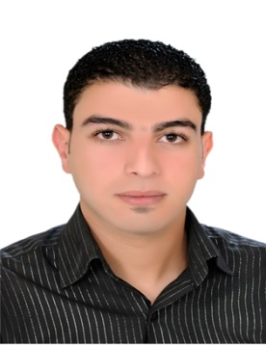

MOHSEN
MOHSEN.159237@2freemail.com

Objectives
Dear
I am writing to express my interest in applying for vacancy at your organization.
Based in UAE, I am currently employed as public Relation Officer.
I have a total of 7 years of full-time work experience. I believe that the skills I have acquired in the course of my professional and educational experiences will be valuable assets for your organization.
Attached are my contact details and detailed CV for your review. I would appreciate the opportunity to speak with a member of your recruiting team in due course. Thank you very much for your consideration.

Personal Information
Name : MOHSEN
Marital Status: Single
Birth Date : 10-02-1987
Nationality : Egyptian
Visa Status : Residence
License car : Avilebul

Education
B.S of Information Systems - Administration Section
Delta Academy– EgyptMay - 2008

Work Experience
Mar. 2009 – Sep 2011: Elmaqam Engineering Consultants, Abu Dhabi

Job Title:PRO

Job Desc. :
- Review submittals to ADM.
- Maintain the municipality system.
- Representing office in any official submittals.
- Filing projects official papers.
- Maintain letters Logs.
- Minute managing partner meetings with clients.
- Issuing building permits to contractors.

Oct 2011– Oct2013: Building complex General Contracting, Abu Dhabi

Job Title : Public relation officer

Job Desc. :
- Strategic planning towards labors work force.
- Fully aware of the review of all government departments from commencing project till close out.
- General Directorate of Residency and Foreigners Affairs paper work and submittals.
- Ministry of Labor paper work and submittals.
- Abu Dhabi Municipality paper work and submittals.

Jan 2014 – Present: Asqalan Group (Dubai & Sharjah & Ajman)
Job Title : Public relation officer

Job Desc :
- Extraction Get Pass security entry and temporary workers (GHQ).
- Extraction Get Pass A truck Permit.
- General Directorate of Residency and Foreigners Affairs paper work and submittals.
- Ministry of Labor paper work and submittals.
- Abu Dhabi Municipality paper work and submittals.
- Follow all transactions of government interests in Dubai (General Administration of Foreign Affairs) (Ministry of Labour)

Computer Skills
- Microsoft office package: Word,Excel,Access and power point.
- ICDL Course.
- IT networking
- Finger print attendance software

Language Skills
- Arabic (Mothertongue)
- English (good)

Drivinglicense
- UAE driving license
- Egypt driving license

Personal Skills
- Communication skills
- Ability to work under pressure.
- Good communication and negotiation skills.
- Flexible, Motivated, Committed to team work, Good organizational skills.
- Developing others and helping others to learn.
- Progressive.
- Hard worker.

References available upon requested

