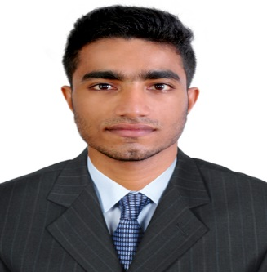
RESUME

NAME: PRANAV
Nationalilty: Indian
E-Mail:pranav.160791@2freemail.com

Objective:
To take up a challenging position in a company that provides an environment conducive to enjoy working, and which utilizes my knowledge, diversified exposure, capabilities and skills towards achievement of company’s mission and objectives through continuous learning and development.

Skills:
My greatest strength is my ability to walk into a new environment and be functional immediately. Having immense self- confidence. High will power to achieve. Willingness to take responsibilities. Understanding the importance of Confidentiality. Ability to learn quickly. Good inter-personal skills and ability to work in-group environment. I am quick to learn and adapt to new situations, configurations and technologies.

COMPUTER SKILLS

- Software testing
- ASP .net
- SQL
- Microsoft Office
- C
- C++
- C#
- java programming
- visual basics
- Power point
- Web designing
- HTML
- Microsoft Word
- Excel
- Internet research and communication tools.
- Windows and Linux operating system

Academic Poject(PG)

Name of the Project | Duration | Language & Database Used
Lawyers Portal | 6 months | ASP.Net, MySQL
Synopsis:-Lawyers portal.
Academic Poject(UG)

Name of the Project | Duration | Language & Database Used
Campus Recruitment System | 6 months | ASP.Net, MySQL
Synopsis:-College website for campus recruitment process.

Personal Skills

- Comprehensive problem solving abilities.
- Ability to deal with people diplomatically.
- Ability to work well with others or independently.

Awards and Achievements

- Participated in University Football Tournament in the year of 2014,2015
- Member of Kannur University Football Team
- Participated in various Sports Events in College.

EDUCATION

Examination | Discipline/  Specialization | Institution | Board/  University | Year of  Passing | Status
Msc | Computer Science | College of  Applied Science, Science, Neruvambram | Kannur  University | 2017 | Completed
BSc | Computer Science | College of  Applied Science, Science, Neruvambram | Kannur  University | 2015 | Completed
Plus Two (XII) | Maths, Physics,  Chemistry, Biology | GHSS Kottila | Board of HSE,  Kerala | 2012 | Completed
SSLC (X) | Kerala Syllabus | GHSS Kottila | Board of  Secondary  Education,  Kerala | 2010 | Completed

Personal Details:

D.O.B | : | 23 April1995
Marital Status | : | Single
Nationality | : | Indian
Languages known |  | English, Hindi, Tamil & Malayalam.

