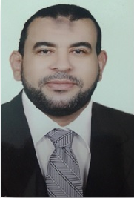 | CURRICULUM VITAE

Personal Information

Name  Marital Status | Mohammed  Mohammed.161084@2freemail.com  Married + 3
Date of Birth 10/07/1974

Military status Exempted

Nationality Egyptians

Address Egypt - Cairo - Helwan

Academic Qualifications

From - To | Major Subjects | Faculty | Degrees | University / Institute
1993/1997 | Business Administration | Commerce | Very good | Institute OF Hejaz
2013/2015 | Master of Human Resource | Commerce | Very good | University OF Ain -Shams
2006/2008 | Diploma Management of Hospitals | Commerce | Very good | University OF Ain -Shams
2006/2008 | Diploma development and Human Resources Planning | Commerce | Very good | University of Al – Azhar

Job Profile

Job Title  Place | Human Resource Specialist  Mental Health Hospital in Helwan
Date of Job 2002 To Date.
Arabic  English  Personal skilles | Native language  Fluent, in speaking and in writing

Place , Authority | Field | Course Description | Year
Helwan University | V.4 | I.C.D.L | 2008
Ministry of Health. | V.19 | SPSS | 2010
Ain -Shams University | 450 | TOEFL | 2013
I

Professional Courses

- Ability to work in groups.
- Work efficiently under pressure.
- Supervising the development, implementation and identifying of the general plan for the human resources management.
- Attracting the Competencies from outside the organization.
- Different Abilities and skills development for all employees depending on the nature of his work through setting training plans (both inside and outside the organization)
- Preparation of reports on the performance of employees, and correcting of workers who are mistaken.

Articles

