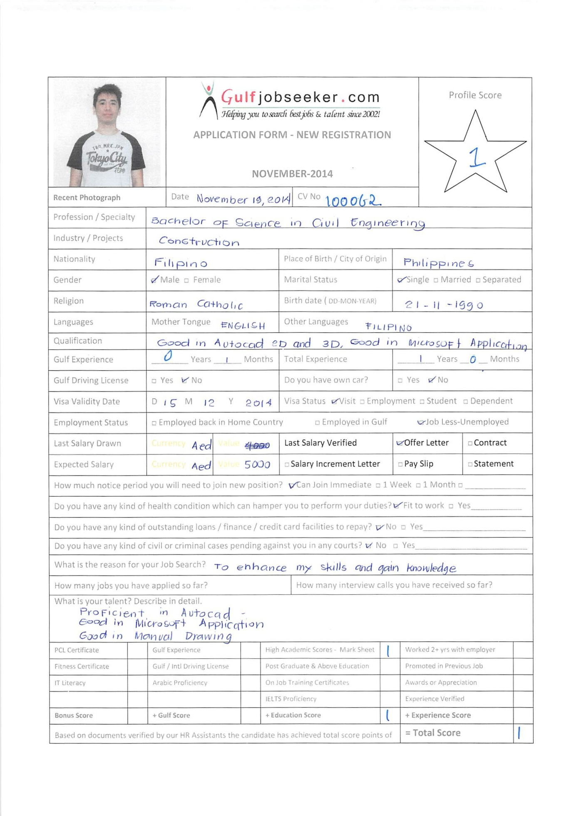
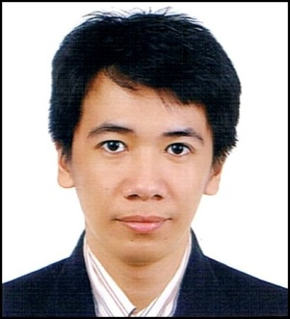

REGISTERED CIVIL ENGINEER
- Philippine Civil Engineer Licensure Examination - November 24-25,2012

Average Rating: 81.60%

TECHNICAL SKILLS
- AutoCAD ( can also perform 3D AutoCAD) , 6 years experience
- Structural Detailing using AutoCAD
- Computer literate in Microsoft Applications ( Word, Excel, PowerPoint)
- Rebar Cutting List using AutoCaD
- Estimator ( knowledge in interior design/ fit-out )
- good communication skills both verbal & written
- Basic Knowledge of Google Sketch-up and Google Earth

WORK HISTORY

CIVIL ENGINEER

September 21, 2014 –November 3, 2014

Job Responsibilities
- Responsible for supervising and monitoring of the project.
- Effectively dealing with the client.

DDT Konstract Inc. is an ISO company that engaged in horizontal development to vertical construction such as roads, bridges, industrial buildings, mass housing, high-end residences/residential condominiums, office buildings and many more.
Project Name: MANILA BAY RESORT

Job Responsibilities:
- Responsible of concrete pouring such as pile caps, lean concrete, pressure slabs, columns, suspended slabs, girders, and beams.
- Ability to command and communicate effectively to foreman, leadman and workers in order to achieve great result of concrete pouring.
- Ability to decide and make solutions whenever problems in construction site are encountered.
- Daily monitoring and observing of construction project to ensure construction practices.
Premiere Fiestaland Inc. is primarily engaged in the development of modern leisure villages, middle income as well as low cost housing projects.
Project Name: RANCHO IMPERIAL DE SILANG
Job Description and Responsibilities:
- Monitoring and estimating of budget for material cost and labor cost.
- Assists in the preparation of construction schedule.
- Prepares weekly construction activity reports.

EDUCATION

Bachelor of Science in Civil Engineering, 2007-2012
Saint Louis University
Baguio City, Philippines

COLLEGE SEMINARS/ TRAININGS ATTENDED
- Fire Protection Engineering
- PASCO–software for Structural Design
- Traffic Engineering Research, Trends and Practice
- State of the Environmental Report and Infrastructure Development

MEMBERSHIP IN ORGANIZATION

- Philippine Institute of Civil Engineers (PICE) , member 2009-2012

PERSONAL BACKGROUND

Age: 23

Birthday: November 21, 1990
Birthplace: Mapandan, Pangasinan, Philippines
Gender: Male
Citizenship: Filipino
Civil Status: Single
Height: 5’8”
Languages/Dialects Spoken: English, Filipino

