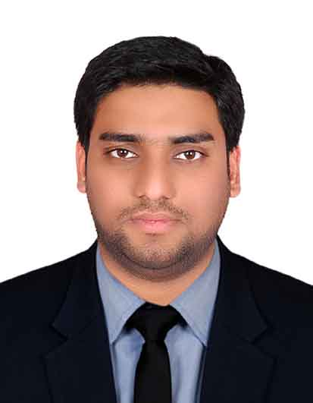  ABDUL  B.TECH. in EEE (Electrical &Electronics Engineering)  Computer Knowledge:  Well-versed with Windows, MS-Office, AutoCAD.  E-Mail:  Abdul.17421@2freemail.com  Personal Data:  D.O.B : 02-Jul-1990  Sex : Male  Nationality : Indian  Marital Status: Married  Languages : English, Urdu  Hindi  Visa Status : Employment  License : Having Valid UAE Driving License | OBJECTIVE  Curriculum Vitae  Looking for a challenging and demanding position in a growth oriented ELECTRICAL consulting/contracting/ construction organizations, where there is ample scope for individual and organizational growth.  TECHNICAL &ACADEMIC PROFILE  2012 B.Tech.in Electrical & Electronics Engineering(EEE) from Jawaharlal Nehru Technological University(JNTU), Hyderabad.  2008 Intermediate(10+2) from Board of Intermediate, Hyderabad.  2006Secondary School Certificate(10th) from Board of Secondary Education,  Hyderabad.  EXPERIENCE  SUMMARY: ELECTRICAL ENGINEER HAVING EXPERIENCE OF 5YEARS AND 3MONTHS TILL DATE.  Present Designation: ELECTRICAL ENGINEER IN TAV CONSTRUCTION AT DAMAC TOWERS BY PARAMOUNT(2B+G+9P+4x60floors) HOTEL/RESIDENTIAL TOWERS.  Period: from October 2016 to till date.  Previous Project: MARINA 101 PROJECT(6B+G+100 FLOORS) HOTEL/RESIDENTIAL TOWER- DUBAI.  Period: from July ’2013 to September 2016.  RESPONSIBILITIES AS ANELECTRICAL ENGINEER  - Preliminary planning based on Architectural drawings.  - Concept/Design discussions with the Clients and Architects.  - Co-ordination with Architectural and Structural teams for all Elec work.  - Organization of works for both Sub-contractors and Main Contractor.  - Checking the weekly and monthly progress, coordinating with Consultant,  - Work at Site: Supervision and Monitoring the Sub-contractor work at site.  - Checking the quality of work as per specifications and approved drawings for all the electrical systems.  - Attending the inspections at site with the concerned authorities (DEWA and Etisalat).  WORKED EARLIER AS AN ELECTRICAL SITE ENGINEER AT UPPALAPATI ENGINEERING PROJECTS (I) PVT. LTD. HYDERABAD.  PERIOD: JULY ’2012 TO MAY 2013.

TECHNICAL EXPERTISE

Certified course in ELECTRICAL DESIGNING and DRAUGHTING from Taiba Engineering Consultants, Hyderabad.

Duration of course: 6 months.
- Designing of LIGHTING and POWER systems

CORE QUALIFICATION

- Excellent knowledge of the installation of electrical systems and equipment
- Understanding of all the applications of electrical engineering
- Great teamwork abilities on group projects
- Excellent communication skills when working with others
- Proficient in mathematics and computer technology
- Capable of reading or writing diagrams and instructions for electrical panels or equipment
- Efficient in time management and able to fulfill deadline requirements

ACHEIVEMENTS

- Participated in events (tree plantation and blood donation) at college level in 2008

HOBBIES

- Playing Cricket.

DECLARATION

I hereby declare that all information provided above is true to the best of my knowledge and belief.
……………………….
(ABDUL)

