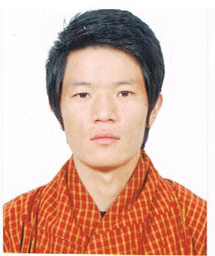Curriculum Vitae

Gulfjobseeker.com CV No: 106386
Mobile +971505905010 / +971504753686

To get contact details of this candidates
Submit request through Feedback Link
http://www.gulfjobseeker.com/feedback/submit_fb.php
Career Objectives
Seeking a job where continuously enhance my knowledge, skills and experience by getting involved in challenging environment and utilize them for personal and organizational growth to the best of my ability.
Vision
To work with fullest involvement and to give my excellence in assigned passionately and to increase efficiencies and upgrade strategic working environment in the organization.
Academic Qualifications
Course School/College Board/University Percentage Year
B.C.A IT and Management Sikkim Manipal 62% 2012
(Computer Application) College Darjeeling, India University, India
Diploma in Hardware Lalani Computer Lalani Academy 81% 2010
and Network Engineering Academy, India Darjeeling, India
Commerce with IT Rinchen Higher BHSCE, Bhutan 55% 2008
Xll (BHSCE) Secondary School,
Bhutan
Work Experience

Sales and Service: 1st /June/2013 to 15th/July/2014
IT Plaza
Bhutan
Responsibilities:
- Consistently offer professional, friendly, warm and engaging excellent customer service.
- Work as a team to achieve the goal and target of the company.
- Maintain a positive and cheerful attitude and co-operative with team work.
- Handing cash register and familiarization of payment through credit cards.
- Responsible for stock take inventory and perfume proper merchandising.
- Responsible for all issued funds and maintain proper handover/takeover.
- Manage product returns and exchanges

Data Entry/Operator in Ministry of Health Royal Government of Bhutan form February 1st – 30th April in year 2013.
Responsibility: Verify accuracy of data, Retrieve information in the right format at the right time, make necessary changes or correction and maintaining extreme confidentiality.
Researcher/Enumerator (Interviewer) in National Health Research Royal Government of Bhutan for 5 years planning from 20th November 2012 – January 31st 2013.
Responsibility: Research in specific area, verifying household, encounter in existing census data and answer questions about health.
Strength
- Flexibility and adaptability  - I’m self-confident and can mould myself to all work environments  - Determine to learn with the practical approach | - Interpersonal relations and communication  - Punctual and hardworking  - Compassion and truthful
Computer proficiency

- MS Office (Word, Excel, Power point)  - Internet Email Application | - Operating System  - Computer Configuration skills and problems solving
Language Known

- English  - Nepali | - Hindi  - Dzongkha (Bhutanese)
Personal Profile
Date of birth : 06th/09/1986
Nationality : Bhutanese
Gender : Male
Marital Status : Unmarried

Deceleration
I hereby affirm that the above information given by me is true to the best of my knowledge. I will be solely responsible for any discrepancy found in it. Thank you very much for the time to consider my curriculum vitae, I will be glad if I am given an opportunity to work with your esteem Organization.

