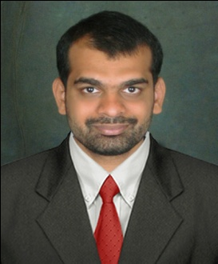
Gulfjobseeker.com CV No: 97836
Mobile +971505905010 / +971504753686

To get contact details of this candidates
Submit request through Feedback Link
http://www.gulfjobseeker.com/feedback/submit_fb.php

Career Objective:
Associate with a Growth oriented organization with determination dedication and discipline, deploy my Competencies towards personal and professional growth.
Personality traits
- Highly motivated and eager to learn new things.
- Strong motivational and leadership skills.
- Ability to produce best result in pressure situation.
- Excellent communication skills in written and verbal both.
- Ability to work as individual as well as in group.

Professional Qualification:
Master of Business Administration (MBA) SDM- Mangalore University. (2012-2014) with 65%
Bachelor of Business Management (BBM) SDM – Mangalore University.(2010-2012) with 53%

Academic Qualification:
Pre - University - Milagres Pre University College, Mangalore (India) with 75%
S.S.L.C - Milagres Junior College, Mangalore (India) with 65%
Skills:
- Working knowledge in computer applications.
Hobbies:
- Travelling, cricket, music.

Academic Project:
Did a summer Internship in NILGIRI’S SUPERMARKET(Mangalore – India) and did a project titling “A study on customer Satisfaction with reference to NILGIRI’S SUPERMARKET” Mangalore.
Designation : Business Development Executive
Duration : 2 months
Responsibilities Interaction with the customers, and enhancing business volume.
Strength:
I can work with concentration and devote my entire energy and time to the task assigned to me
Personal Information:
Date of Birth : July 23, 1991
Marital Status : Single

Nationality : Indian
Languages Known English, Hindi, Kannada, Tulu

References : Will be provided on request

The above information provided by me is true and to the best of my knowledge. I look forward to an opportunity of being a team member of your Organisation and I assure you of my best services at all times.

