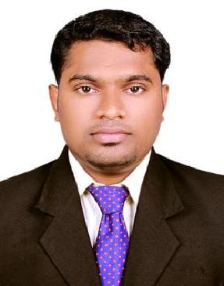

AREAS OF EXPERTISE

Financial reporting

Strategic business reviews

Performance reporting

Business development

PLUS P OINTS

Post-Graduation in Business administration

Accomplished accounts all-rounder

TALLY Software certified

PERSONAL PLUS

Ability to work in a multi-cultural environment

Good communication and leadership skills

Can acquire new skills quickly

Gulfjobseeker.com CV No: 98004
Mobile +971505905010 / +971504753686

To get contact details of this candidates
Submit request through Feedback Link
http://www.gulfjobseeker.com/feedback/submit_fb.php
PERSONAL SUMMARY
A multi-skilled and competent individual with good all-round Finance expertise, also interested in HR. I am an MBA graduate with successful finance background. Experienced in general Accounting strategies and analyzing the Business trends. A productive team player, accustomed to work to deadlines, self-motivated, organized and able to multi task.

Now looking for a managerial level Finance or HR job which has something to do with Business Administration. One which will make best use of my skills, experience and education and also further my development.

WORK EXPERIENCE
SHAHRAYAR RESTAURANT GROUP – UAE

Chief Accountant (2 Years) 2012- 2014

Was Working as Chief Accountant at Shahryar Restaurants main branch. My key activities are as given below,

Duties:

- Managing all the financial activities of all the branches
- Preparing daily sales reports
- Preparing WPS Salary
- Approving purchase activities
- Preparing petty cash
- Maintain all staff details
- Reporting all financial activities to top management

KEY SKILLS AND COMPETENCIES
- Excellent analytical and negotiation skills
- Strong Technical Knowledge
- Good business sense
- The ability to motivate and lead a team
- Initiative and enthusiasm
- Excellent communication and 'people skills'
- Good planning and organizational skills

ACADEMIC QUALIFICATIONS
MBA (Master in Business administration)

Anna University, Trichy - India

Bachelor Degree (B.com)

Calicut University, Kerala - India

