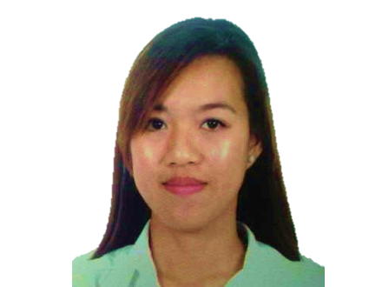

Gulfjobseeker.com CV No: 979608
Mobile +971505905010 cvdatabase[@]gulfjobseeker.com

To contact this candidate use this link

http://www.gulfjobseeker.com/feedback/contactjs.php

OBJECTIVE:
Looking for an opportunity to utilize my knowledge and skills in dental care by working in an excellent health care center that is known in providing efficient dental care services to people.

QUALIFICATIONS:
- Dedicated and patient focused Registered Nurse, skilled in Medical-Surgical Ward and critically ill patients.
- Extensive experience in assisting in dental procedures such as preparing patients and sterilizing and preparing the instruments and materials used in dental procedures, handing the dentist the right instruments and taking x-rays and impressions.
- Efficient in performing various dental office duties such as scheduling appointments for patients, billing, keeping records of the treatment, receiving payments, etc.
- Can communicate in English and Arabic Language

EDUCATION:
- Bachelor of Science in Nursing (March 2006)
Union Christian College, Philippines
- Diploma in Associate in Health Science Education (March 2004)
Union Christian College, Philippines
- Licensure Examination for Nurses in the Philippines
Reg. No. 0423387 valid until April 2015
- Licensure Examination for Health Specialties, Riyadh Saudi Arabia
Reg. No. 08-R-N-0216392

WORK EXPERIENCE:
AL AWAL DENTAL CENTRE, RIYADH SAUDI ARABIA
April 2008 – May 2012
Dental Nurse
- Promptly follow the instructions of the dentist and perform various dental procedures
- Order and stock supplies of instruments and medication
- Sterilizing dental equipment and making sure the correct equipment is available and in good repair
- Prepare dental materials such as composite, cements, impression material, amalgam, etc.
- Assist patients by instructing about oral hygiene and other plaque control techniques
- Fix appointments and maintain treatment records
- Perform laboratory procedures, maintain dental equipment and develop dental x-rays
- Helping to keep the patient as relaxed and happy as possible.
- Ensuring that patient condition is not contraindicated to any dental procedure.

BETHANY HOSPITAL INC., PHILIPPINES
September 2007 – March 2008
Staff Nurse
- Delivered a complete range of RN services and expertise.
- Accurately obtained and documented patient history and medication list, assessed individual conditions and needs and selected department referrals for acute and chronically ill patients.
- Prepared equipment and assisted physicians during patient examinations and treatments.
- Monitored patient reaction to drugs and carefully documented progress of individuals participating in clinical trials.
- Maintained patient medical and health records.

LA UNION MEDICAL CENTER, PHILIPPINES
May 2007 – July 2007
Volunteer Nurse
Training and exposure in nursing care and skills in different wards and departments like Out-patient departments, Medical ward, Ob ward, Surgery/Orthopedic Ward, Emergency room, Intensive Care Unit, Pediatric ward and Nursery.

CERTIFICATES:
- Basic Pre-hospital Emergency Case: First Aid and Basic Life Support - CPR Training
- Career and Seminar Workshop
- International English Language Test System
Taken on October 27, 2012
Listening 7.5 Speaking 7.0

I certify that all the above information is true and correct

