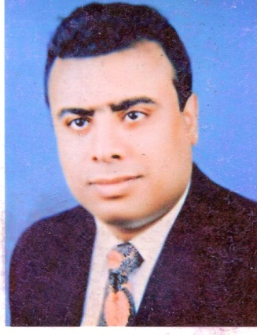
Raed
Raed.163603@2freemail.com

Name: raed
My Carerr Any position

Date.of.Birth 12/4/1969 Nationalyty Egyption Visa status tourism
Driving License issued by Saudi Arabia
Experience 25 yearsﻓ FROM 4/2015 TO 6/2017
Hotel Manager
Management of Hotel Nelover Branch KHOBAR **** (Saudi Arabia)
----------------------------------------------------------------------------------------------------------------------
FROM 9/2013 TO 4/2015
Hotel Manager Management of Nelover Hotel Riyadh Branch of Cordoba**** (Saudi Arabia)
----------------------------------------------------------------------------------------------------------------------

FROM 1/2012 TO 2/2013

General Manager

Management of Zelda Foods Company Egypt
------------------------------------------------------------------------------------------------------------------------------

FROM 2/2009 TO 11/2011

Hotel Manager

Management of Ocean Blue Hotel Ain Sukhna Egypt*****
-----------------------------------------------------------------------------------------------------------
FROM 5/2007 TO 1/2009
House keeping Manager

Ocean Blue Hotel Marina Egypt *****
-----------------------------------------------------------------------------------------------------------
FROM 7/2000 TO 1/2004

Assistant Manager of Housekeeping

Grand Hyatt Hotel in Amman Jordan*****
--------------------------------------------------------------------------------------------------------------------------------
FROM 6/1990 TO 9/1999

Front Offices Manager
Suwailim Hotel in Dawadmi Saudi Arabia**

----------------------------------------------------------------------------------------------------------------------------------------------------------------------------------

Skills
      - Ability to work under pressure
      - Training all employees on the best job
      - Develop appropriate plans for income growth
      - Studying the Positive and negative of operating
      - Ability to solve problems and make a decisionde

-----------------------------------------------------------------------------------------------------------------------------------------------------------------------------

------------------------------------------------------------------------------------------------------------
The Hotel Manager is directly responsible for:

Strategic: To oversee the development of the overall operational strategy of the hotel with special focus on the food and beverage operations, the annual business plan and budget.
Financial: To ensure that the Revenue and GOP targets of the property is delivered. Successfully position the hotel from a food and beverage perspective. To ensure that accurate forecasting and Revenue Management activities are taking place
Leadership: To be the contact point of the line management of the property, responsible for the make-up of the executive team and succession planning of all leadership positions of the hotel.
Owner Relations: To support and effectively manage the owner relationships on behalf of the company
Operational Quality. To oversee the consistent and successful implementation of the programmes to ensure that the operational and service skills of the employees of the hotel are being constantly improved.
- Hotel audits and surveys
- Guest satisfaction
- Employee engagement surveys
- Departmental workshops across all departments
- Internal audits against hotel SOPs

