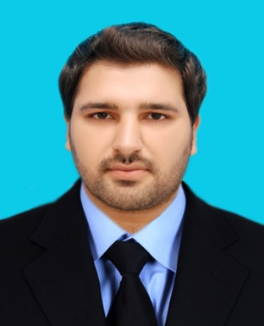

Hedayat

Hedayat.163798@2freemail.com
Personal Information
Visa Status: Visit till Nov 2017
Gender: Male
Religion: Islam
Marital Status: Unmarried

Objective
I am looking to secure a position with an your Organization where I can use my abilities, experience and contribute to a performance-oriented environment, set and achieve growth and profitability targets, and constantly look to improve my own performance and that of my employer.

Education
- Master of Business Administration (HRM) 2015-17
CGPA 3.5
Institute of Management Sciences Peshawar
- Bachelor of Business Administration (Finance) (2010-14)
CGPA 3.8
Iqra National University Peshawar
- Higher School Certificate (Pre-medical) 2006-08
Ist Division (60%)
Board of Intermediate & Secondary Education Malakand
- Secondary School Certificate (Matric Science) 2006
Ist Division (73%)
Board of Intermediate & Secondary Education Malakand

Work Experience

- Rural Development Organization, Dir Lower, Pakistan
- Data Entry Officer Oct, 2009-March,2010

Key Responsibilities:

- Updated record of IDPs of Swat & Malakand as a member of implementing partner with United Nation World Food Program.
- Baseline and Endline surveys and data assessment.
- Prepare Daily Report Weekly and Monthly Reports.
Any other tasks assign by manager.

SHED Peshawar, Pakistan
Data Management Officer March, 2015 –Aug 2015
Key Responsibilities:

Providing health and psychosocial support to IDPs of Bara Khyber Agency as a member of implementing partner of UNOCHA.
Baseline and Endline surveys and data assessment.
Prepare Daily Report Weekly and Monthly Reports.
Any other tasks assign by manager.

ZEAL FOOD & BEVERAGES PVT LTD

- HR & A Officer January 15, 2017 –August 09, 2017
Key Responsibilities:

- Ensure that all activities and documentation is handled in the strictest confidence within the HR department.
- Ensure effective administration and full documentation for Human Resources department covering every activity, issue, grievance, etc.
- Providing payroll information to Finance department at the end of each month
- Ensure administrative support for staff recruitment, interviews, new employee orientation & administration of close of service procedures
- Develop and undertake induction and orientation for all new hires.
- Ensuring employee performance evaluation system at field level.
ACHIEVEMENTS:

- Provide consultancy to “Ample the Consultant” organization for HR policy and HR manual. An academic assignment.
- Communication, Leadership & Presentation Skills. Attended six days training program at IQRA NATIONAL UNIVERSITY Organized by IDEA and Supported by Peshawar Uplift Program.
- Member of Drugs Free World International Organization USA.
- MS OFFICE: Frequently used MS-Excel, MS-Word and MS-PowerPoint, Email and letter writing, printing letters, formats designing and presentations.
- SPSS- Trained in SPSS for research work at university.
- Research Thesis on effects of Perceived organization support on Organization Citizenship Behaviour and employee turnover intention. Master’s degree final thesis
- Research Thesis on Effects of financial crises on stability of banks-An evidence of Pakistani Banks. Bachelor degree final thesis.

Other Interests:
- Books Reading
- Traveling
- Internet Suffering

References:
Will be furnished upon request.

