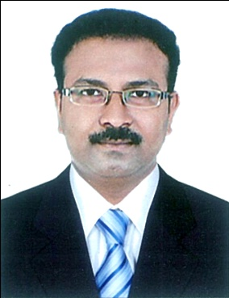
ANESH ELKA

email:- ANESH.164286@2freemail.com

CREER OBJECTIVE:

I am well versed with accounting procedures both local as well as international. Multi-tasking is my forte along with keen analytical skills and lateral thinking ability. Meticulous and work driven by nature, I am essentially a team player and have demonstrated good leadership skills in previous jobs.

EDUCATIONAL BACKGROUND:

1996–1999 Bachelors in Commerce Kerala, India
University of Kerala

1993-1995 Pre-Degree (Commerce Group) Kerala, India

WORK EXPERIENCE:

03-12-2011 to 29-12-2012 Accounts Clerk, Pixel Informatics, Kerala, India

Responsibilities
- Preparing employee salary details
- Preparing invoices & company audit
- Prepared supporting documentation whenever customers or auditors required

10-04-2010 to 20-10-2011 Cashier cum accountant, Akbar Restaurant, Dubai, UAE
Responsibilities
- Assist in monthly payroll .
- Making suppliers Cheque’s and issuing the Cheque’s to the client with dated and post dated
- Filing and updating weekly Ledger Account
- Drawing cash from bank
- Internet research for new accounting standards and techniques
- Balanced entries, organized documents and debits and credits, verified statements and totals with records

10-04-2006 to 31-03-2010 Cashier cum accountant, Little Hut Restaurant, Dubai, U A E
Responsibilities
- Preparing employee salary details
- Bank reconciliation
- Making suppliers cheques and issuing the cheques to the client with dated and post dated
- Handled day-to-day journal entries, reports, and income/sales, sales receipt deposits, bank account reconciliation, and performed various routine adjustments to company documentations, records, logs, journals, etc
- Utilized on a daily basis the accounting system of the company and assisted with monthly reports and invoicing

02-04-2004 to 28-02-2006 Receptionist (Cashier) Night Auditor, Hotel Horizon,Kerala, India
Responsibilities
- Overall operational responsibility of the reception such as guest check in/check out, foreign currency exchange, night auditing, handling EPABX, fax etc
- Coordinating and maintaining communication and relations with all the other departments ensure smooth operation of the department
- To lead and be the part of the team at any given time in the performance of basic operational duties
- Keep records of room availability and guests accounts
- Compute bill, collect payment and make change for guests
- Make, confirm and cancel reservations for guests
- Deposit guests' valuables in hotel safe or safe-deposit box

COMPUTER SKILLS:
Operating System
- Windows 98, NT, 2000, XP, Windows 7

Software’s
- MS Word, Excel, PowerPoint and Access
Packages
- Personal computer software (p c s)
- Tally 7.2, 9.1

PERSONAL DETAILS:
Nationality : Indian
Marital Status : Married
Date of Birth : 13-05-1977

Date of Issue : 08-012-2009
Date of Expiry : 07-12-2019
Languages Known : English, Hindi. Malayalam, Tamil

VISA DETAILS:
Visa status : visit visa
Visa validity : 10th April 2013.

