SANGAIAH

Sangaiah.164481@2freemail.com

HR Manager,
HR Department.

SUB: Application for the post of Quantity Surveyor.

READY TO JOIN IMMEDIATELY
VISIT VISA
Dear Sir/Madam,

I would welcome the opportunity to build my career in your reputed organisation. I submit my resume as attachment for your perusal.

I am a Diploma graduate in Civil Engineering

If my qualifications and practical experience matches any vacancies within your organization, I would welcome the opportunity to demonstrate my abilities to achieve goals and complete tasks in a timely and thorough manner. I assure you that I will give of my best for the progress of your organization.

I am enclosing herewith my Resume for your kind consideration. Hope for a favorable response from your end for which act of kindness I shall ever be grateful.

With regards,
SANGAIAH

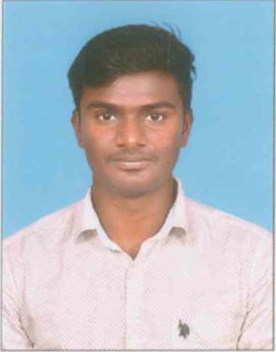

SANGAIAH

Career Objective:
Seeking a career that is challenging and interesting, and lets me work on the leading area of technology, a job that gives me opportunities to learn, innovated and enhance me skills and strengths in conjunction with company goals and objectives.
Work Experience:

Junior Quantity Surveyor (Facade)
KEF Infrastructure India private limited.
July 2017 - Present

- Measurement and valuations of installations
- Checking and verifying quantities.
- pricing of variations in site instruction.
- Certification of subcontractors.
- maintaining subcontractor invoices and certifying payments.
- negotiation with sub contactors.
- submitting progress claims.
- prepared payment invoices and interim
payment certificates
- Maintained quantities for final account and variations purposes.
- Prepared wages and monthly bill for subcontractors.
- monitored and verified subcontractors payments
- assessed additional cost of design variations
- Coordinating QS between the work sites and head office
Junior Quantity Surveyor (Facade)
M/s Geotrix Building Envelope Pvt. Ltd.Bangalore
Jun 2014 - Jun 2017

- Verification of Contractors running and final bills as the contract conditions.
- Physical measurement of quantities and tracking the productivity.
- BOQ(Bill Of Quantity) preparation of projects.
- Reconciliation of pre issue materials.
- Maintain the vendor records.
- Estimation of quantities as per drawing.
- Rate analysis of extra items.

Training and Certification:
60 days training at Mohamed Sathak Polytechnic Collage for Structural Glazing.

Academic Profile:
- Diploma in Civil Engineering (DCE) in First Class [69.68%] from Mohamed Sathak Polytechnic Collage, Kilakkarai, Ramanathapuram, TamilNadu.
- SSLC passed in First Class [80%] from De Britto Higher Secondary School, Devakottai, Sivakangai,TamilNadu.
Strengths:
- Ability to grasp new ideas and technologies.
- Work under challenging situations.
- Leadership qualities.
- Team player.
Personal Profile:

Full Name Sangaiah
Father’s Name Sethuraman R
Mother’s Name Bharathi S
Languages Known English, Tamil

Declaration:

I hereby declare that the information furnished above is true and complete to the best of my knowledge.

Place: Bangalore yours truly,
Date:

