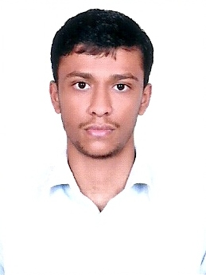
HABEEB

Commerce Graduate with Diploma in Indian and Foreign Accounting

CAREER OBJECTIVE

To work in the most challenging job with an organization that provides ample opportunities to learn and to contribute.

EDUCATION

Bachelor of Commerce (B Com) – March 2012, University of Calicut, Kerala

Plus Two – Mar 2009, Board of Secondary Education, Govt of Kerala

SSLC – Mar 2007, Board of Secondary Education, Govt of Kerala

Computer Knowledge: MS Office

Accounting Package: Tally, Peachtree.

TECHNICAL QUALIFICATIONS:

DIPLOMA IN INDIAN AND FOREIGN ACCOUNTING – Jun 2014

WORK EXPERIENCE
- Organization: Al Mubarak Hypermarket, Al ain, Abu Dhabi. From 10th September 2015 till date.

Designation: Cashier

- Organization: Kudumbini Super Market Shornur, Palghat, Kerala. From Jan 2015 to Aug 2015.

Designation: Accountant

Duties and responsibilities:
- Dealing with day to day Accounting transactions, Cash, Bank & JV’s entries in the software.
- Preparation of Bank reconciliation Statement.
- Accounts payables.
- Checking Local Purchase Order.
- Purchase Invoice entry checking.
- Billing and receipts.
- Responsible for maintaining accounting ledgers and performed account reconciliation.
- To Maintain Records of Payment Information.
- To process accounting Transactions.
- Managing vendor accounts including payments.
- Checking Trial Balance & Balance Sheet.
- Payroll.
- General Accounting.

- Organization: A M Traders, Ottapalam, Palghat, Kerala. From Oct 2014 to Dec 2014.

Designation: Accountant

Job Profile: Day to Day Accounting, Payments, Receipts, Payroll, Data Entry & Billing.

- Organization: Malabar Steel Company Pattambi, Kerala. From Nov 2013 to Aug 2014.

Designation: Accountant

Job Profile: Day to Day Accounting, Payments, Receipts, Payroll.

Languages Known:
- English - Read, Write, Speak
- Hindi - Read, Write, Speak
- Malayalam - Read, Write, Speak
- Arabic - Read, Write

Permanent Address:

POOVATHINGAL House
NEDUMPURA.PO
CHERUTHURUTHY VIA
THRISSUR (Dist)
Kerala –

