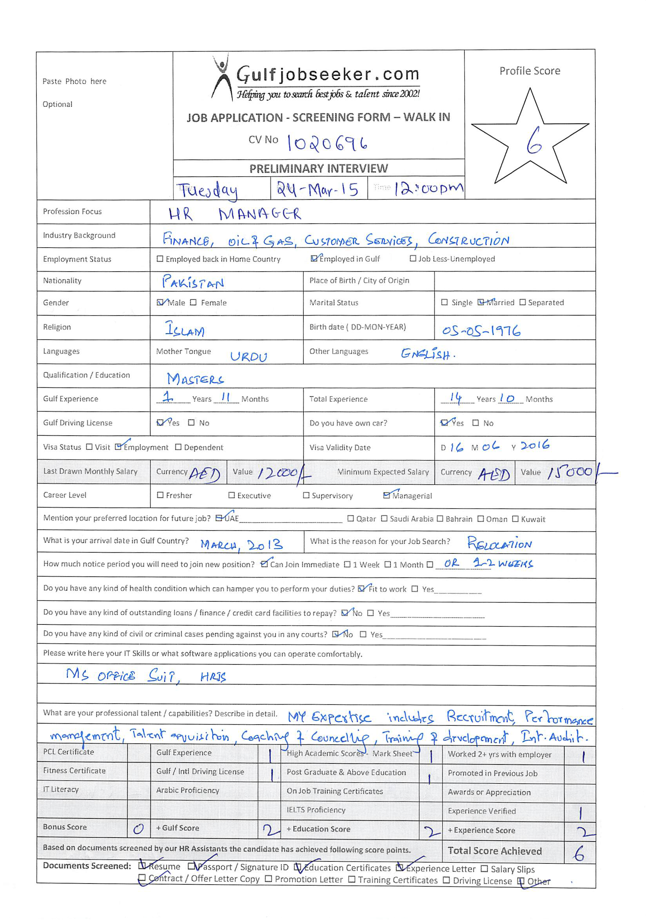

 |  | 
Highly competent professional committed to develop, employ and maintain professional human resources system that meets top management needs. Equipped with MA Degree in Human Resource Management from reputed university in UK effectively utilized in directing whole gamut of manpower management encompassing planning, full cycle recruitment, orientation, training and development, performance supervision and personnel relations. Also astute and proven in handling broad-based functions such as general office administration, business operations management, business development, project support, sales-marketing, client relatations and customer service. Possesses high level analytical aptitude, problem solving capabilities and zest in shaping challenges into concrete achievements hence heavily relied upon for valued opinions in key decision-making. Proactive, well organized and enthusiastic team leader with excellent communication, interpersonal, organization and coordination skills with presentable personality and professional business style.

STRENGTHS
- Performance management with EDPs | - Business Operations & Administration Orientation
- Vast Knowledge in Recruitment Life Cycle | - Strategic Planning – Business Development Adept
- Superb Coordination with Cross Functional Team | - Policies Development – Implementation Capabilities
- Problem solving & grievance handling | - Drive in Attaining Desirable Objectives
- Exceptional Communicator & Leader | - High Sense of Commitment & Responsibility

Qualifications
Master of Arts in Human Resource Management, London, UK |  | 2005
Master of Commerce (Commerce & Business Trade), University of Baluchistan, Quetta, Pakistan |  | 2000
Potential Leadership Program (1 year), Institute of Leadership & Management (ILM), London, UK |  | 2010

Career Snapshot
Manager HR & OPS |  | May 2013 – Till date
Albwardy Engineering Enterprise is a division of Albwardy Investment Group. Established in 1977, Albwardy Engineering Enterprises is managed by a team of professionals in different disciplines and has the distinction of completing prestigious projects including residential & commercial buildings, luxury villas,7 star hotels and its management etc.
Bus. Ops/HR Manager |  | Sep 2010 – April 2013
JNB associates are renowned, consultants, deals in recruitment HR, Financial, legal and corporate services. The Business Office is located in Lahore, Pakistan.

Support Manager |  | Jun 2007 – Jul 2010
Centrica, top 30 FTSE100, is an integrated energy company operating predominately in the UK and North America. The company is part of British Gas, UK's leading energy supplier.

Business Operation/HR Manager |  | Oct 2004 – Apr 2007
Lifestyle Mortgages is a reputed financial, mortgage and business development consulting firm.

Personal Financial Consultant |  | Dec 2002 – Sep 2004
Standard Chartered Bank is oldest and largest foreign commercial bank in Pakistan with 162 branches and over 9000 employees.

Administration & Accounts Manager |  | Jul 2000 – Sep 2002
Global village is one of the largest software house and ISP, based in Karachi and Quetta.

Areas of Expertise
Human Resource Management
- Oversee the human resources operations of the entire business such as recruitment, training and development, compensation, benefits and employee relations.
- Supervise the entire life cycle of performance management and individual development plans.

Cont’d...

- Manage motivation and training of the entire staff; work with them to ensure that they had the skills, knowledge and motivation to carry out their roles effectively.
- Determine training needs, implement training procedures, prepare training manuals and conduct training as well as ensuring training effectiveness by consistently creating pre-post assessment tools.
- Manage staff welfare through team building or recreational activities to improve productivity output and motivation levels. Amend programs as necessary to adapt to changes occurring in the work environment. Assign tasks to subordinates as daily responsibilities and ensure compliance for such. Evaluate each employee performance plus check if they adhere to set rules, policies-standard procedures in performing delegated tasks.
- Lead implementation of performance management system that includes performance development plans (PDPs) and employee development programs. Evaluate work performance plus human constraints.
- Deal with understaffing, resolving conflicts and administering disciplinary procedures.
- Plan human resource requirements in coordination with various functional and operation heads.
General Management (Administration & Operations)
- Direct whole gamut of activities directly related with strategic planning, budgeting, sales-marketing, customer service and staff administration. Ensure smooth flow of business, maximum sales profitability, increase in customer satisfaction and continued business growth.
- Achieve financial targets by preparing strategic plans and budget.
- Set short and long range goals, objectives, policies and operating procedures.
- Liaise with different departments to coordinate activities, exchange information, and resolve issues and concerns and to ensure timely implementation of objectives.
- Maintain accurate and up-to-date records of company papers and pertinent documents.
- Review financial statements, sales and activity reports, or other performance data to measure productivity, goal achievement; determine areas needing cost reduction or program improvement.
- Conduct a periodic analysis on performance versus goals and provide response to higher management on ROI (Return on Investment), Profitability and all deviations from set goals.
- Facilitate employment of corrective action where adverse variations to target achievement occur or inadequate performance is suspected. Instigate actions to bring about necessary improvements.

Business Development & Project Management Support
- Help manage company’s projects and activities aimed to deliver continued business growth.
- Cooperate in defining goals, milestones, tasks, time, and resource and personnel utilization.
- Provide assistance in organizing and coordinating activities of all personnel to ensure delivery of projects within parameters of time, cost and quality consistent with client requirements.
- Support team and all staff working with project. Ensure atmosphere that allow personnel to implement development in the most cost-effective manner.
- Track progress of project viz. budgeted costs, quality, timelines, and standard to ensure that project specifications and approved parameters are met.
- Represent the company in contract negotiation, finalization and signing.
- Resolve contract or subcontract issues, disputes, terms/conditions, etc.
- Present interim results and carry out reviews.

Proven Job Role
Manager HR & OPS
- Overseeing whole gamut of activities within Business Development, Operations with proactive analytical approach.
- Complete recruitment cycle, for different sites, project and offices in MENA region.
- Improving organizational development, addressing succession planning, employee engagement and development towards a high performance culture.
- Developing and delivering HR strategy in order to fully align with the business plan and achieve objectives. Consistent in developing HR policies, procedures & practices.
- Performance management with coaching and counselling.
- Change management and talent accusation on a large scale, manpower planning and budgeting.
- Carrying out comprehensive analyses focus on different facet of organization’s operation: recruitment-placement analysis for projects; revenue optimization review for Project and Facility Management Departments.
- Actively building and establishing effective relationship with business managers to influence the HR strategy and its operational involvement.
- Representing company in negotiations with financial institutions and private and government agencies, including
Ministries, RERA, chamber of commerce, ministry of labour.
- Complete hands on UAE labour law and country’s other laws.

Administration/HR Manager
PDPs Performance development plans
To manage project operational expenditures and budget for recruitment/training etc.
All Admin work including project’s recruitment etc.
To support the process of performance management (setting performance objectives, feedback and performance review, etc.)
Analyze & finalization of HR reports on monthly, quarterly & yearly basis
Reward and recognition every quarter.
Preparing and support for business development plans
Support Manager
- Closely monitored data processing of business development.
- Senior member of recruitment team.
- Spearheaded own business unit whist officiating other units, specially training and employee engagement.
- Administered whole section besides rendering assistance in engineering compliance and telesales-marketing.
- Dealt with all admin related concerns and took part in problem-solving and decision-making functions.
- Worked collaboratively with other departments primarily with engineering and support divisions.
- Provided efficient support in handling wide range and diversified duties related with operational activities, general office administration, human resource supervision and business development among others.
- Prepared various reports for the overall business operation, sales, complaints and quality audit including recovery analysis. Accordingly submitted the same for top management perusal.
Business Operations/HR Manager
- Facilitated development of HR procedures and policies for effective recruitment, training, performance management and internal audit.
- Consolidated and furnished reports to GM.

Personal Financial Consultant
- Led BDOs/Credit Officers Team: set individual target, supervised works and conducted performance evaluation.
- Branch level recruitment/interviews.
- Acting Branch Manager on various occasions.
- Internal audit and compliance champion
- Managed promotion and marketing of new business opportunities to ensure maximized business portfolio.

Administration & Accounts Manager
- Supervised Human Resource, legal and industrial affairs.
- Administered HR strategic planning including duly implementation of financial and budgetary controls.
- Handled banking transactions and reconciliation.

IT Skills
MS Office Suite, Internet & E-mail Applications, SAP,HRIS

Personal Details
Nationality | : | Pakistani
Date of Birth | : | 5th May 1976
Marital Status | : | Married
Driving License | : | UK & UAE

References
Will be furnished upon request

