Bhawna  Bhawna.170567@2freemail.com | 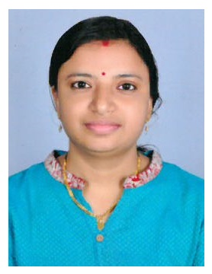

Career Objectives:

Well presented with exceptional administrative and telecalling skills, Experienced in working under pressure in a quick paced fast moving environment and able to receive customers and visitors on arrival in a friendly, helpful and approachable manner.
Able to be an integral member of an administrative and clerical team, and can follow instructions and also have a willingness to learn.

Work Experience in UAE: 3Years

1. Express Print Publishers Dubai, UAE (2YEARS)

Designation: Admin Support cum Telecalling Executive (12-01-2011 to 29-12-2013)

Responsibilities:

Handling a busy switchboard reception and dealing with front office jobs, like to attend all incoming and directing to appropriate department, Keeping all documents and files safe in the right location, taking care of all stationeries of front office, responsible for incoming and outgoing couriers and other documents. Drafting latters. Receiving incoming cheques and cash giving to finance department. Entering data’s which are given by the administrator in excel sheet.

As a telecalling Executive making calls to respective companies and updating information’s of company by telephonic conversation in directories and KOMPASS. Making data sheets for the sales team. Telesales of our Magazines, advertisements space in our directories and Kompass.

1. Beam Sky View trading (3-05-2010 to 30-11-2010)

Designation: Receptionist

Responsibilities:

As a admin support handling telephone calls transferring to the right departments, handling faxes and emails. Greet visitors and guests. Making appointments for interviews and arranging them. Sending and receiving couriers. Drafting latters. Making appointments for interviews and calling them as directed by the General Manager.

3. Al Bayan Al wahda Contracting Company (7-06-2007 to 28-02-2009)

Designation: Receptionist cum Secretary

As a receptionist cum secretary responsible for all works of control reception area, greeting visitors and guests, informing the department.

Here i was responsible to make invoices and quotations, attending meetings with manager making payroll and time sheets for employees. Drafting latters, also recruiting employees for our company.

Academic Qualifications: Bachelor in Science (B.Sc chemistry)

Technical Qualification: Diploma in Web Designing and Programming.

.

Declaration:
I hereby declare that all the statements are made in the applications are true and correct to the best of my knowledge.

