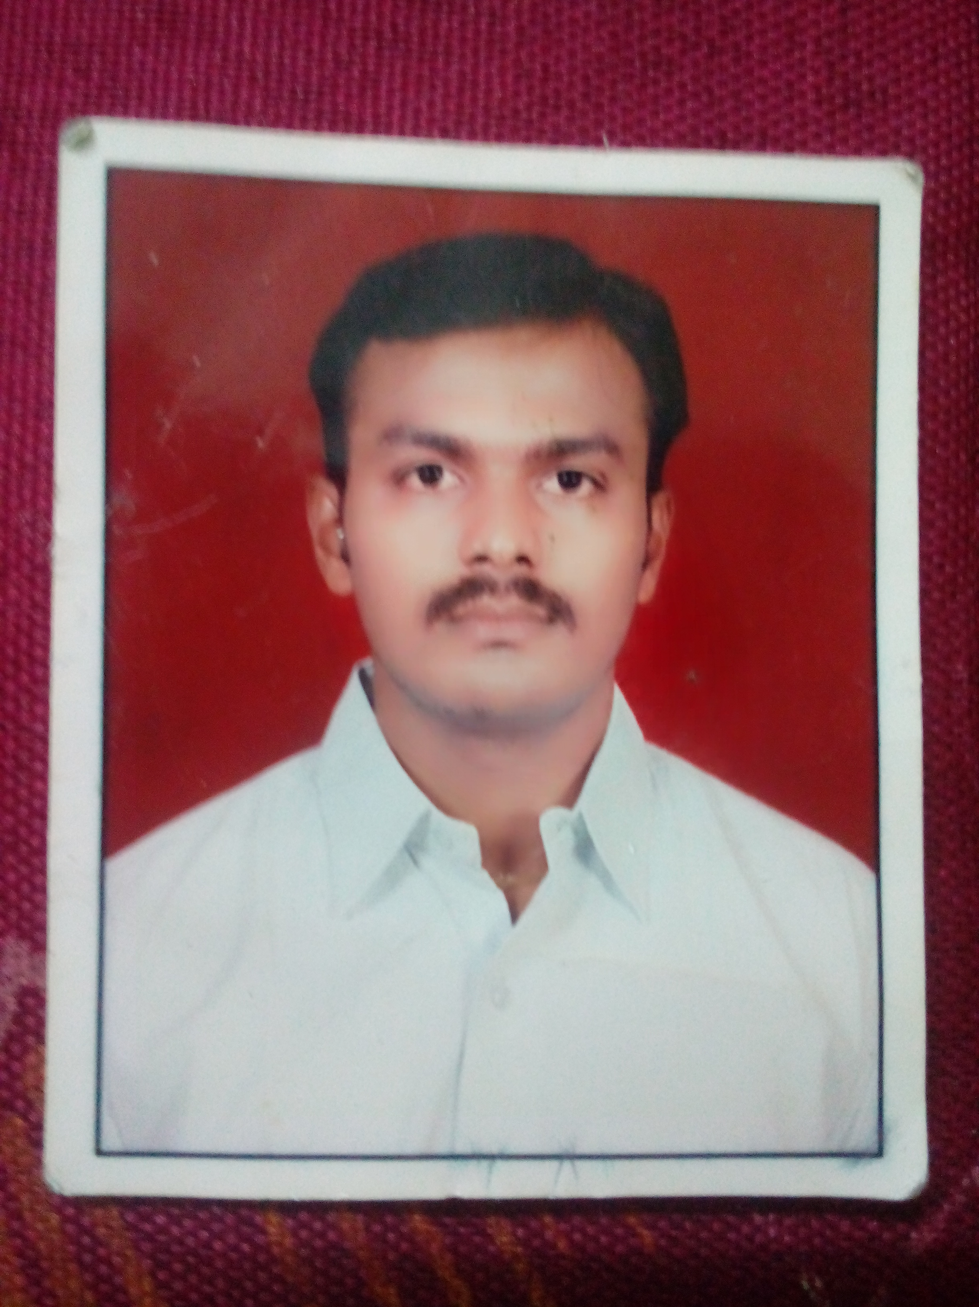

Curriculum Vitae
Varun | Mail: varun.174627@2freemail.com

Vision

To pursue a career in developing and delivering quality products and processes, that demands a high level of energy and expertise and satisfies my passion for quality and quest for learning.

Career Summary

- 8.5 years of multi-functional work experience in best manufacturing practices with world renowned trainers.
- Experience in ISO-TS,TPM.

Work Experience

 | Company | Period
1 | M/s Knitvel Needles (P) Ltd – Hosur - India | May2013 to Aug2017
2 | M/s S & K Engieers – Panth nagar - India | March 2011 to March2013
3 | M/s Assocated match industries - Nigeria | Oct 2009 – Jan-2011
3 | M/s M and M Auto Industries Ltd – IMT manesar - India | Jul 2006 – Sep 2009

Education

S.No. | Qualification | Institution | Year | Marks
1  3 | Higher Secondary +2  Bachelor of Engineering  (Mechanical Engineering) | N.S.V.V Hr Sec School, Pattiveerenpatti.  Trichy Engineering college - Trichy | Mar’2002  Apr ‘2006 | 79 %  69%

Additional Qualifications :

- Knowledge in Auto CADD 2009.
- ISO-TS System development, member of CFT team.

PRESENT JOB:
Currently designated as Asst Manager - MAINTENANCE with M/S Knitvel needles (P) LTD, Hosur. The said company has been certified ISO 9001:2008, ISO 14001:2004 , Manufacturer, Marketing, Sales Tier1 suppliers of Ashok Leyland, TVS, TAFE, manufacturing of machined and fabricated components for two wheelers, needles and sheet metal components for commercial vechiles.,

Period of Work: May2013 – Till Date

RESPONSIBILITIES:
- Planning, implementing, documenting activities for minimizing breakdown of all machinery and equipment and recording
- Maintenance and upkeep of machines and equipment, condition layout
- Ensuring tools and dies are maintained, assembled, inspected, prepared for timely die change / mounting with required documentation
- Reduction of Die change time
- Controlling consumption of consumables, spares, power and fuel
- Generation and implementation of ideas, suggestion for improvement, actively encouraging, small group, cost control activities and achieving KFO’s
- Optimum utilization of resources
- Breakdown, Preventive & Predictive maintenance of the below;
- Press Machineries
- CNC bending machines
- Cooling tower
- Chimney & Accumulator
- Compressor & Genset
- Drying chamber
- Special purpose machines etc.,
- Training given for sub-ordinates
- Manpower planning and work allotment
- Material follow-up activities
- Attending production meeting and discussing issues related to breakdown
- Understanding and implementation of customer requirements down the line
- Implementation of Kaizen
- Maintain appropriate records & documents as per ISO 9001:2008, ISO 14001:2004 system requirements
- Responsible for safety in the plant

PREVIOUS JOB:
Designated as Sr.ENGINEER – MAINTENANCE with S & K Engineers LTD, Panthnagar. The said company has been certified ISO/TS 16949:2009, Manufacturer of pressed and fabricated components like Front fork, Muffler, Bar foot rest, Head lamp bracket, , Pneumatic body for Two and Four wheelers(Automotive Applications) and Machined components for major Customers like Bajaj Auto ltd etc.,

Period of Work: March 2011 – March 2013

RESPONSIBILITIES:
- Initiate to maintain the machinery’s in good condition to avoid any breakdowns
- Ensure timely attendance of breakdown in the event of any machine breakdown
- Ensure daily routine maintenance activities and lubrication( if required)
- Maintenance of spares with appropriate quantity
- Ensure periodical preventive and predictive maintenance for the machines
- Maintenance of fire extinguishers and periodical refilling
- Good up keep of machines and to reduce breakdown
- Poke Yoke implementation for avoiding mistakes
- Interaction with subordinates to reduce the machine breakdowns
- Planning of manpower and work allotment
- Interaction with production department in the event of any technical issues
- Material follow-up activities
- Implementation of kaizens in the shopfloor
- Implementation of 5’S activities

Previous Job:- M and M Auto Ind Ltd – IMT manesar

M and M Auto Industries Limited, an ISO: 9001:2000 and ISO/TS: 16949:2002 certified company, was established in 1991 and is an ancillary to Hero Honda Motors Ltd,Munjal Showa ltd, Endurance system (I) Ltd.,Gabriel India Ltd., Rico Auto,FCC Rico,Majestic Auto and Bosch Rexroth France. The company is into manufacturing of different types of compression, extension, torsion, spiral springs, some wire forms and sheet metal components towards achieving zero defects.

Designation: GET & Maintenance Engineer.
Period of Work: May2013 – Jul 2006 to Feb2011

Personal Details

Age & DOB : 32 years & 26 June’ 85
Sex : Male
Marital status : Married

Languages (Read/write/speak) : English(R/W/S), Tamil (R/W/S) Telegu (s) Hindi (S)

References upon request.

