Prithviraj
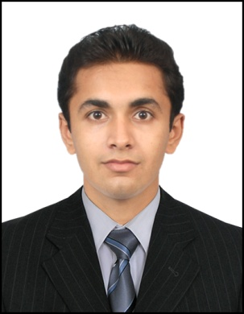

Specialization: BUSINESS and PROGRAMMING

Career Objective: To contribute to the Organisation’s goals by consistently exceeding utilization in Customer Service, Programming skills, System Hardware support, Junior Admin Support, and Sales.

Education:

Qualification | College Name | University/ Board | Year of passing | Percentage  (%)
SSC | St. Patrick Convent High School | PUNE UNIVERSITY | MARCH 2008 | 71
HSC | Dr. Gujar Shubhash Jr. College | PUNE UNIVERSITY | FEB 2010 | 59
BCA | ASHOKA COLLEGE | PUNE UNIVERSITY | April 2013 | 64

Achievements:
- Came 2nd in inter-college competition held in B.Y.K college for Software Development
- Supervisor at my current job(Co-UAE EXCHANGE CENTRE LLC)
- Got certificate of appreciation from my CEO for achieving business goals.

Work Experience:

- Currently working in Uae Exchange Centre LLC as supervisor and Branch Compliance officer.
- Worked at computer hardware showroom for one year in India as a system hardware engineer in year 2012-2013.

Computer Skills:

- Operating Systems: Windows, DOS

- Packages Known: MS Office (Word, PowerPoint, Advance Excel),Desktop Publishing

- Language: C ,C++, VB, VB.NET, JAVA, DBMS, DBMS(SQL,ORACLE,ACCESS)

Extra Curricular Activities:

- Advance Diploma in Software Engineering
- Advance Diploma in Hardware Engineering
- Done a project on Airline Reservation System in VB.
- Done a project on Hospital Management System in VB.NET

Personal Details:

Date of Birth: 03/08/1992

Marital Status: Single

Strengths:
- Excellent Interpersonal Skills
- Self Disciplined
- Highly Diligent and Committed
- Team player
- Ability to adopt and learn new technologies
- Understanding
- Hard working

Languages: English, Marathi, Hindi & Sindhi

Visa Status: Employment

I HERE BY CERTIFY THE ABOVE DETAILS ARE TRUE & CORRECT ACCORDING TO THE BEST OF MY KNOWLEDGE.

Prithviraj CV NO. 1067910

Click to send CV No & get contact details of candidate

