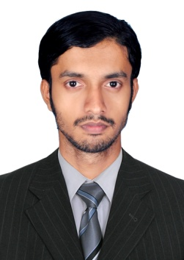

Gulfjobseeker CV No: 110190
To interview this candidate call: 971505905010
Or email us back filled up Vacancy Form
http://www.gulfjobseeker.com/Free_Job_Posting_Form.doc

DESKTOP SUPPORT ENGINEER WITH 3 YEAR EXPERIENCE
Areas of Expertise:

- Ability to provide solutions for computer hardware and software problems
- In-depth knowledge of testing and upgrading
- Possess good supervising and training skills
- Ability to maintain good relationship with clients
- In-depth knowledge of installation and troubleshooting
- In-depth knowledge of various network tools and applications
- Ability to perform task independently under pressure
Technical Skills:
- Knowledge of operating systems like Windows 98, Windows 2000, Windows XP, Windows Vista, Windows 7, Windows 8, LINUX, Fedora.
- Knowledge of Software like MS Office, , Video Editing & Mixing, Photo Editing ….etc
- Knowledge of Networking – Win Server 2000,2003/2008,
- System Hardware & Software Maintenance.
- UPS Maintenance
- Cabling & crimping for systems, hubs, switches & routers
- Installation and trouble shooting of application softwares
Professional Experiences:

- COOL LAND Electronics, Riyadh, Saudi Arabia.
Duration : April 2014 to December 2014
Designation : Computer operator
- HCL INFOSYSTEMS LTD Kannur, Kerala, India.
Duration : November 2012 to April 2014
Designation : Customer Engineer in INDIAN NAVAL ACADEMY
Ezhimala (November 2012 to April 2014)
- BITS & BYTES INFOSOLUTION Payyannur, Kerala, india
Duration : August 2011 to October 2012
Designation : Service engineer
Academics: 2011 Associate Member of Institution of Engineers (AMIE)
ELECTRONICS AND COMMUNICATION ENGINEERING.
2009 Board of Technical Education Kerala, India
DIPLOMA IN ELECTRONICS ENGINEERING
2006 Higher Secondary Education Department Kerala, India
PLUS TWO (SCIENCE)
2004 Board of Public Examination Kerala, India
S.S.L.C.
Languages:
- English (Read, Write & Speak)
- Hindi (Read, Write & Speak)
- Malayalam (Read, Write & Speak)
- Tamil (Speak)

Personal Details:

Age & Date of Birth : 25 years; 17/04/1989
Sex : Male
Marital Status : Single
Visa status : Visit Visa
Hobbies
- Drawing
- Reading
- Photography
- Playing cricket

