CURRICULUM VITAE

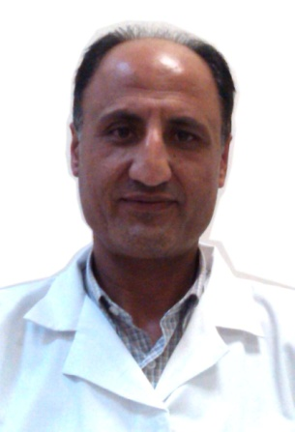

MUSAHIB

Musahib.19647@2freemail.com

ACADEMIC QUALIFICATION

- MBBS, University of Peshawar April 2000
- Underwent Training in Family Medicine 2011

CLINICAL EXPERIENCE

1st Oct 2005 to date General Medical Officer
Tayma General Hospital
Tayma, Tabuk, KSA

9th May 2001 to Sep 2005 Medical Officer
Fauji Foundation Hospital
Projects, Pakistan

1st Dec 2000 to 31st May 2001 Senior House Officer
Department of Surgery
PGMI, Govt. Lady Reading
Hospital, Peshawar, Pakistan

1st Jun 2000 to 30th Nov 2000 Junior House Officer
Department of Medicine
PGMI, Govt. Lady Reading
Hospital, Peshawar, Pakistan

SUMMARY

Started working in a tertiary care hospital like PGMI Govt. Lady Reading Hospital gave me great exposure of dealing with out-patient as well as emergency cases and in-patients. Working as medical officer in Fauji Foundation Hospital Projects enriched my clinical experience as I was carrying out mobile visit to the peripherals areas of Kohat City, in addition to the routine clinical work inside hospital.

Currently, I am working as emergency medical resident in Tayma General Hospital, Tayma, Tabuk region, KSA since 1st October 2005 to date.

OBJECTIVES

To secure a challenging position in an environment which provides opportunities to fully utilize and improve my medical knowledge and education in a congenial atmosphere. I want to carry out post-graduation in general practice.

HONOURS

- Registered with Pakistan Medical & Dental Council Via
- Registered with Saudi Health Specialties via
- DHA approved (Assessment completed, Eligibility letter issued)

GENERAL SKILLS

- I can communicate in multiple languages like Pashto, Urdu, Arabic and English (7Score in IELTS each module)

