# CURRICULUM VITAE

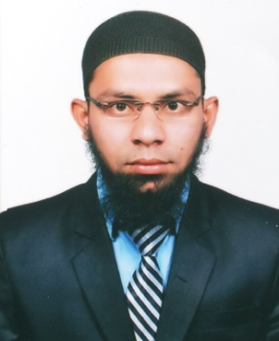

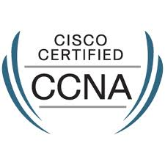

**ARSHAD**

E-mail: [arshad.182443@2freemail.com](mailto:arshad.182443@2freemail.com)

## Job Objective:

Seeking middle level assignments in System Administration / Desktop Support / VMware Virtualization Network Administration/with a leading organization of high repute preferably in Gulf Countries/Middle East.

## Profile Summary:

* A focused and result oriented professional with nearly 2 years of experience in:

System Administration Server Administration Network Administration

Installation & Configuration Technical Support VMware Virtualization.

* Expertise in handling installation & configuration of Windows 2008 Server, Outlook 2007 and VMware Centre.
* Dexterous in managing Active directory forest, domain controller migration.
* Proficiency in managing and administrating user accounts, assigning group policies & permission to share folder and disk quota.
* Proficiency in Hyper – V and VM ware.

## Certifications & Training:

* Cisco Certified Network Associate (CCNA)

Certification ID: **CSCO12510321**

* Microsoft Certified Technology Specialist (MCTS) Windows Server 2008

Certification ID: **10417384.**

* MCITP (Windows Server 2008)

## Core Competencies:

* Monitoring IT projects with respect to budgeted cost, demand forecasts and time over-runs to ensure timely execution
* Installing servers, server administration & peripherals and designing domain/file server.
* Designing the Backup Strategy for sites and ensuring scheduled/ unscheduled Backups as per backup plan and restoration
* Resolving the hardware as well as networking problems of different clients
* Maintaining the installation, migration and the configuration of domain controller, active directory, child domain controller/ IIS, windows and application troubleshooting
* Handling installation & configuration of operating systems, applications, servers & workstations
* Sustaining Directory including security domains, user profiles.

## Organizational Experience:

**Since Jan – Oct, 2013** **net Harbor Technologies Pvt. Ltd.** **Hyderabad, India.**

**As System Administrator**

Responsibilities:

* Maintaining user accounts and user rights assignment.
* Creating and managing users and groups accounts in Active Directory domain environments.
* Installation and configuration of servers services (Domain Controller, DNS, DHCP, ISA, File server, Backup server, print servers, and antiviruses)
* Cisco switches configuration
* Join new computer to domain and define all services link printers and scanners.
* Configuring Active Directory Services
* Configuring Terminal Services
* Configuring Trust relation between forests.

**Feb 2012 – Dec, 2012 net Harbor Technologies Pvt.Ltd.Hyderabad India.**

**As Desktop Support.**

Responsibilities:

* Demonstrated expertise in configuring, installing and troubleshooting PC systems.
* Desktop support (Windows deployment and support)
* MS-office, IE explorer support
* Account operation over active directory
* Configure L2 switches
* Supported installation and configuration for DIS card printer
* Configuring and maintaining E-mail clients like MS outlook, Outlook Express.
* Outlook configurations and archive emails to .pst format

**As Hardware & Network Engineer:**

* Good understanding of networking routing, switching (CISCO).
* Strong Knowledge of TCP/IP and network administration/protocols.
* Strong knowledge of routing protocols especially EIGRP/OSPF
* Pleasant personality and ability to trouble shoot IT issues.
* Responsible for maintaining the systems (Installation, Configuration, Customization, Data Migration).
* Understanding various spheres of Network.
* Undergone corporate training for 3 months in CCNA.

## Education details:

* 2008-2012 **Jawaharlal Nehru Technological University, Hyderabad, India.**

Bachelor of Technology with computers science and engineering.

* 2006-2008 **Board of Intermediate, Hyderabad, India.**

* 1993-2006 **Higher secondary school.**

## IT Skills:

Operating Systems : Windows 2003, 2008, XP, Vista, Windows 7 & 8  
Database : SQL Server 2005, Oracle 10g  
Internet Protocols : HTTP, HTTPs, SMTP  
Email : Outlook 2007   
Web Servers : IIS 5.0 & 6.0

Packages : MS-office (Word, Excel, Power Point)

**Personal Details**

Date of Birth : 04 may, 1991

Nationality : Indian

Gender : Male

Marital Status : Single

Visa Status : Visit Visa

Date of Expiry : 04 MAR 2014

Languages Known : English, Urdu, and Telugu.

**Place: DUBAI, UAE Arshad.**