Shemin
Shemin.184415@2freemail.com
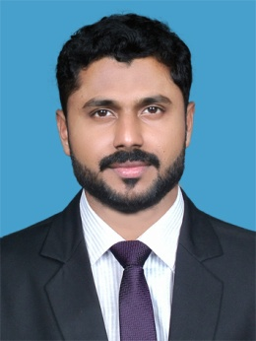

Career Objective

To be associated with a progressive organization which can provide me with a dynamic work sphere to extract my inherent skills as a Professional, use and develop my aptitude to further the organization’s objectives and also attain my career targets in the progress.

Competencies

- Excellent energy for Maximum utilization of all resources
- Excellent energy-level, people & time management, resourcefulness, negotiation, teamwork and ethics.
- Able to adapt easily to people from various nationalities and work under pressure.
- Ability to work with individuals at all levels with in the organization.
- Excellent in MS Office and Project designing tools.
- Knowledge in Practical Accounting.
Experience Summary

Organization : Al Samar Elect Devices Tr Est llc
Location : Sharjah
Nature of Work : Computerized Accounting & Manual Accounting
Position : Accountant General
Period : From April 2015 – April 2017

Organization : Designs Textiles & Redimades
Location : Pandikkad
Nature of Work : Manual & Computerized Accounting
Position : Accountant
Period : From Jan 2014 – Jan 2015

Organization : M/s Accounts (Accounts Contractors) Location : Cochin – Kerala – India. Nature of Work : Manual & Computerized Accounting Position : Accountant Period : From Sep 2010 – Oct 2013
Reference : P.V. Paulose M/s Accounts, Ambadi lane, Cochin -35. India, Ph.0484-2384684
Responsibilities
- Control over all Accounting and Financial matters.
- Handling and maintaining Accounts up to Finalization
- Preparation of year ending Schedules and Accounts for Audit
- Reconciliation of: - Bank, H.O, Branches, Debtors, Creditors and Stock.
- All kinds of Bank Transactions.
- Maintaining Purchase & Sales including Stock Register
- Maintaining all kind of Data Entry Operations.

IT Proficiency
Operating Systems:

- Windows 8, Windows 7,Windows XP , Windows 2000 professional
Others:

- Microsoft office (2003, 2007 & 2010)
- Advanced knowledge of Accounting package Tally 7.2, 9 & ERP 9
- Good Knowledge in PGDCA.
- Certified in Desk Top Publishing (DTP)

Academic Chronicle

- B.Com (University of Calicut)
- PLUS TWO (Board of Kerala)
- SSLC (Board of Kerala)

Personal Details

Nationality : Indian
Marital status : Married
Gender : Male
Languages Known : English, Hindi,Arabic and Malayalam.
Visa Status : Employment visa is cancelled.

Declaration: - I hereby declare that all the facts mentioned above are true to the best of my knowledge and can provide proof whenever required.

