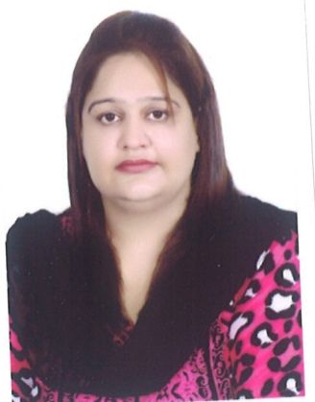
Saima

Saima.185525@2freemail.com

PERSONAL STATEMENT

I’m an experienced Accountant looking for a new opportunity within a large or small operation in UAE
I have previous experience in corporate accounting and small business accounting

Education
B.COM

Technical Skills
- Outlook
- Word
- PowerPoint
- Excel
- Accounting software

EMPLOYMENT
Accounts Officer
M.Saleem& Co.

Achievements
- Worked successfully with lead junioraccountants in completed close procedures in extreme deadlines.
- I produced the Monthly bank reconciliations of the all bank accounts posting all transactions to the ledgers.
- Established and maintained an effective system for analyzing and reporting
- I was in charge the company patty cash during my time Accounts Global
- Recovering benefit overpayments, maintaining a database and handling enquiries.
- Monthly billing, follow ups the company receivable
- I dealt with the weekly payments.
  - Fortnightly staff Expenses
  - Fortnightly payment of invoices for groups overseas companies
- Expedited administration routines and made the filing system more efficient.

Assistant Aaccountant
Textile Marketing Co.
- Bank Reconciliation Daily as well as Monthly
- Sale Purchase entries & Preparation of Contracts
- Payable & Receivable Reconciliation
- Reconciliation of Stock At Godown
- Commission Bills & Their Follow Up
- Handling All Office Correspondence
- Data entries in Accounting Software

